**Hands on lab – ORACLE DIGITAL ASSISTANT**

04.12.2024

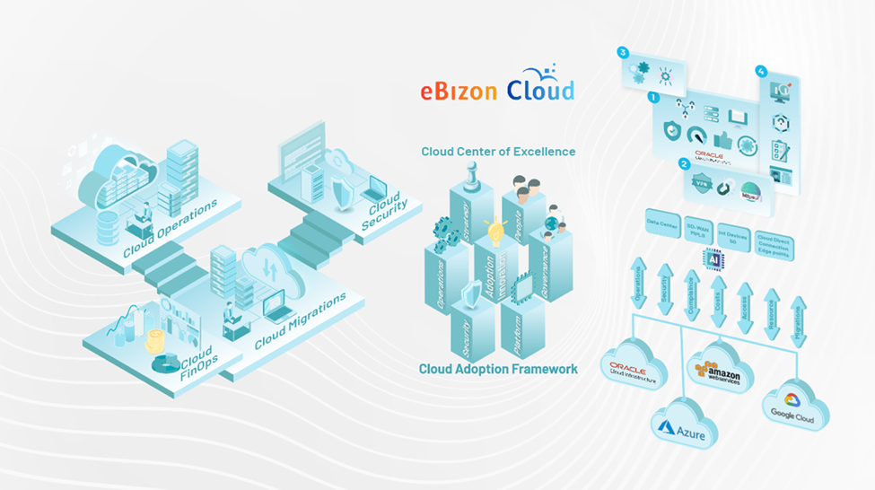

Prakash Ganesan | Ebizoncloud LLC

**Table of Contents**

INTRODUCTION 2

OCI environment and lab notes 3

Sign in to the lab environment 3

Live cloud environment 3

Setup the lab environment 7

Create a Skill 11

Create Intents 15

What is the difference between trainer HT and trainer TM? 21

Test your Model 23

Create Entities 32

Design the Dialog Flow 45

Test your Skill 60

Integrate your Digital Assistant with a Visual Builder app 63

# INTRODUCTION

Oracle Digital Assistant is a platform for developing chatbots driven by artificial intelligence (AI) that enable users to accomplish a range of tasks through natural language interactions.

In this lab, you will create a **digital assistant**and a **skill** that can be used for interactions with a pizzeria, including ordering pizzas and cancelling orders.

To build a skill for a digital assistant, you will create the following components:

**Intent**

Intents allow your skill to understand what the user wants it to do.

For example, "I want to order a Pizza" and "I feel like eating a pizza" are direct intents that a digital assistant can recognize as user requests to order a pizza.

**Entities**

While intents map words and phrases to a specific action, entities add context to the intent itself. They help to describe the intent more fully.

For example, the **PizzaSize** entity identifies values like "large", "medium", and "small" from the user's input. This is a crucial information for ordering a pizza.

**Design flow**

You will use the **Visual Flow Designer**to create the dialog flow definition, which is the model of the interaction between a skill and its users.

You will define the sequence of prompts, responses, and actions it will take to provide a good conversational experience.

In hands-on-lab we will address the needs of Mama Maggy's digital transformation initiative by creating a digital assistant:

* Build a pizza ordering system skill.
* Create the dialogue flow using the dialogue flow management interface.
* Display the digital assistant on the company website.

## OCI environment and lab notes

* Oracle Cloud Infrastructure (OCI) is a dynamic, constantly evolving environment. As you work through your lab, you may find that the lab guide instructions and screenshots may not exactly match what's in the lab environment. If you encounter a difference that you think we should be aware of, please let us know by sending us an email using the contact information below. Thanks for helping us keep our labs up to date for everyone!

# Sign in to the lab environment

## Live cloud environment

This training provides a live hands-on lab environment for you to practice the skills being presented. You'll have the opportunity to perform all of the tasks and build this solution in a real OCI cloud environment created just for you. Follow the instructions below to launch the virtual desktop where you will launch a cloud environment to practice the steps along with the lab guide below

To start the lab environment, right-click the **launch** button below, and choose **Open Link in New Window**.

Position the new window relative to the lab guide so you can follow the instructions and execute the commands in the lab environment side by side at a size and orientation that's comfortable for you and your screen size.

Once you've launched the lab environment, click Continue below to proceed with the lab.

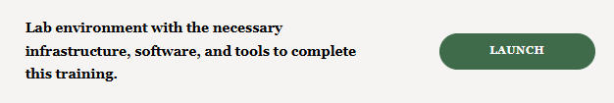

**When you're ready, your desktop should look similar to the image below.**

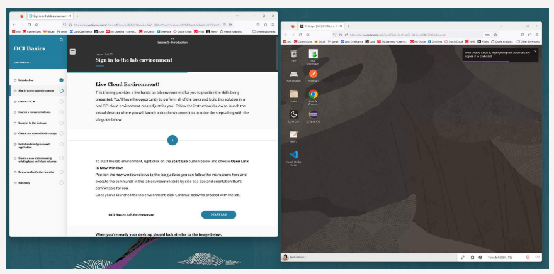

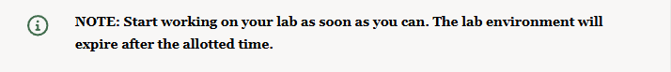

On the desktop, double-click the **Luna Lab** icon. A web page will open to display Oracle Cloud Infrastructure credentials and information specific to your lab.

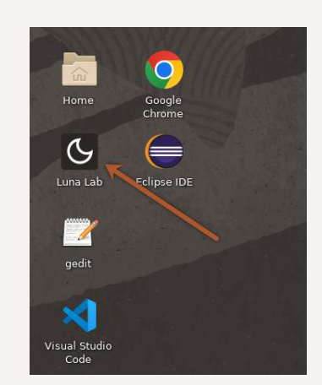

Click the link under **Quick Links** labeled OCI Console. The Oracle Cloud sign-in page will open in a new browser tab.

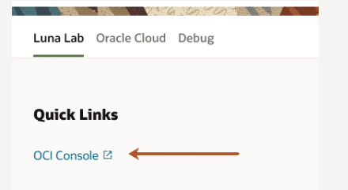

Use the credentials provided on this page.

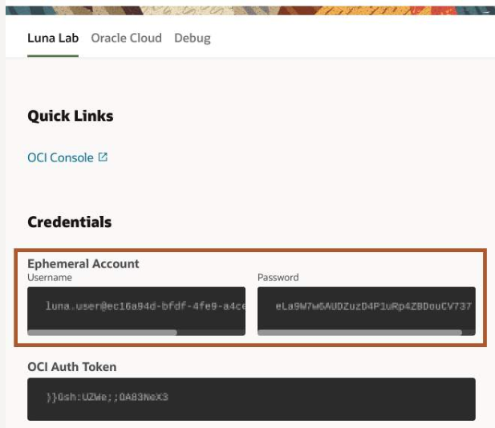

Copy and paste the credentials and click **Sign In**.

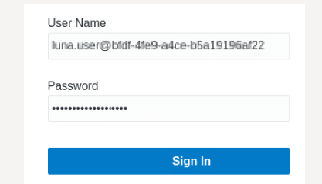

The Oracle Cloud Infrastructure Console homepage opens. You are now ready to start your lab!

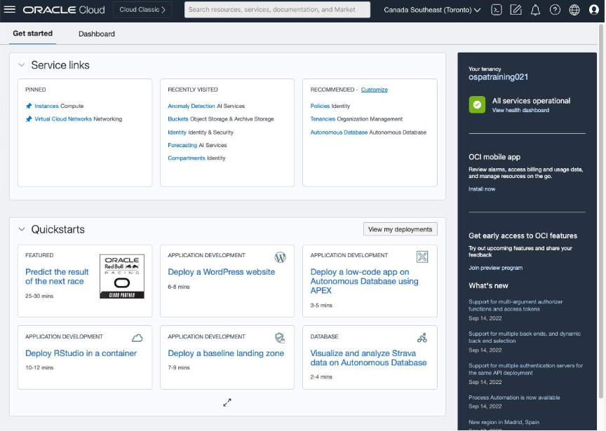

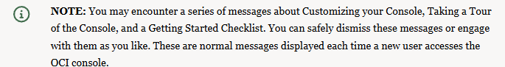

# Setup the lab environment

Like other Oracle Cloud services, you must create an instance of **Oracle Digital Assistant (ODA)**before you can start using it.

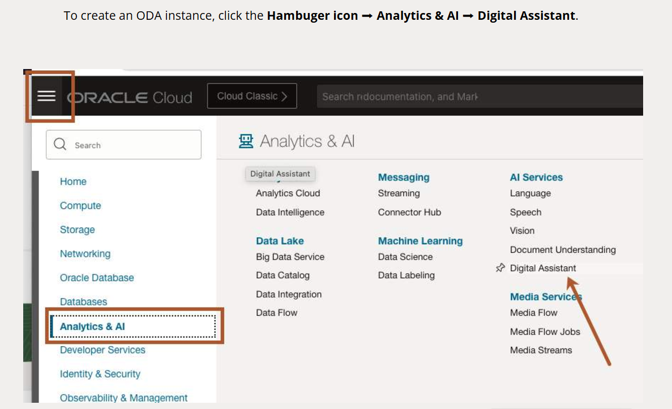

Click **CREATE INSTANCE**

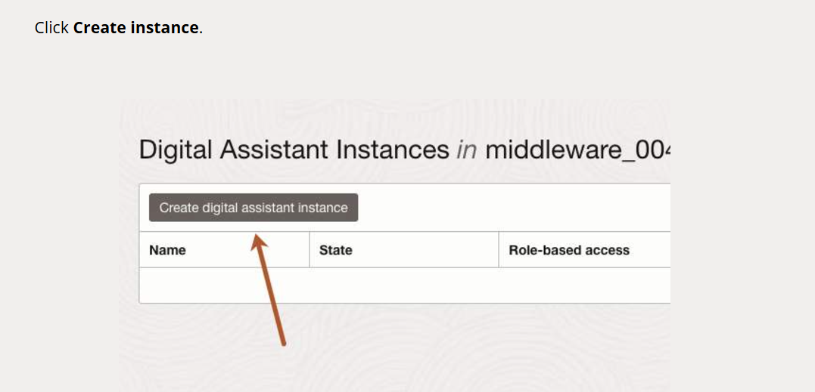

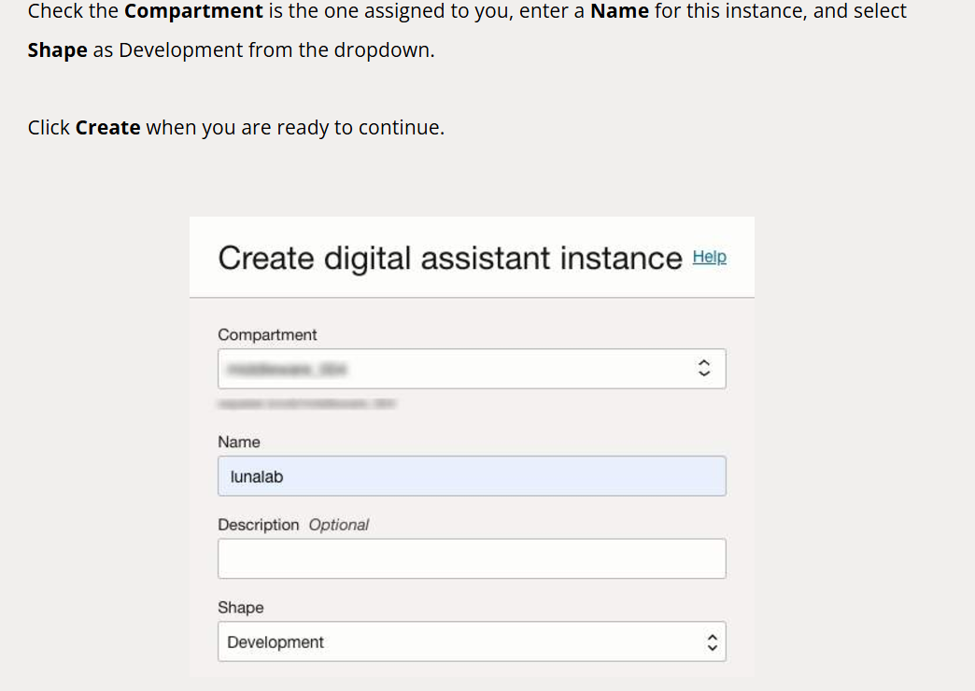

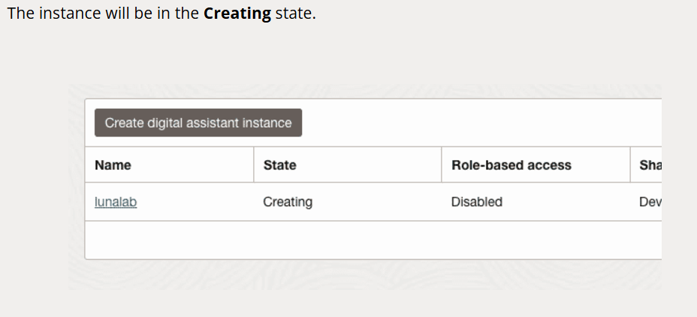

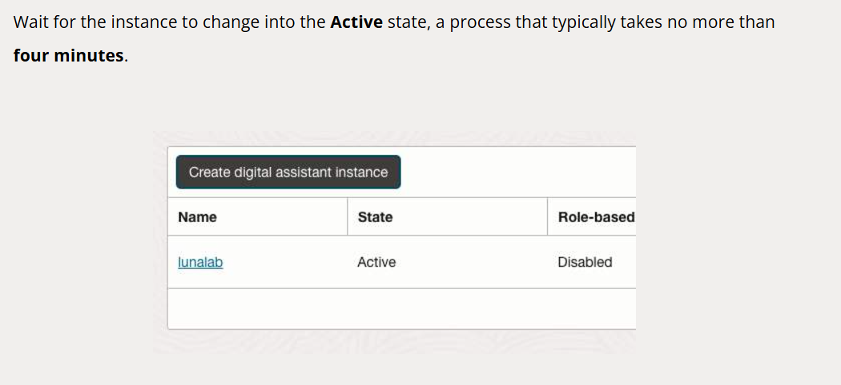

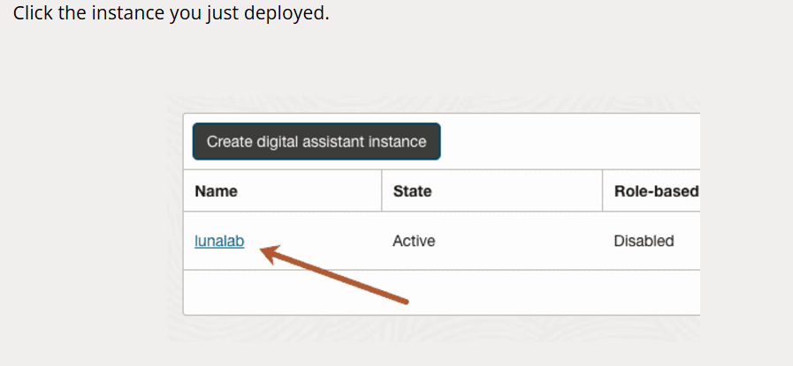

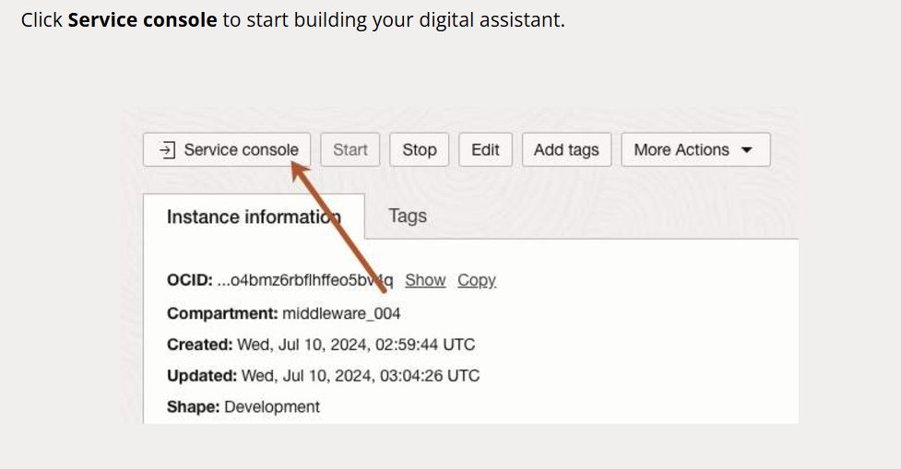

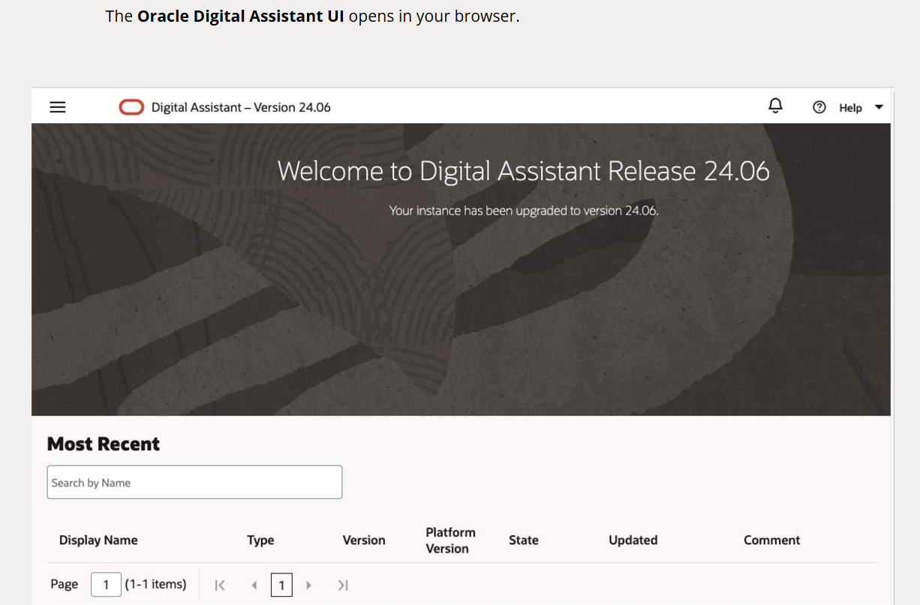

# Create a Skill

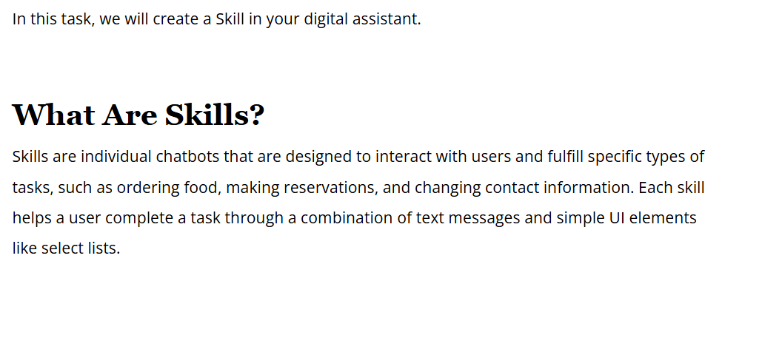

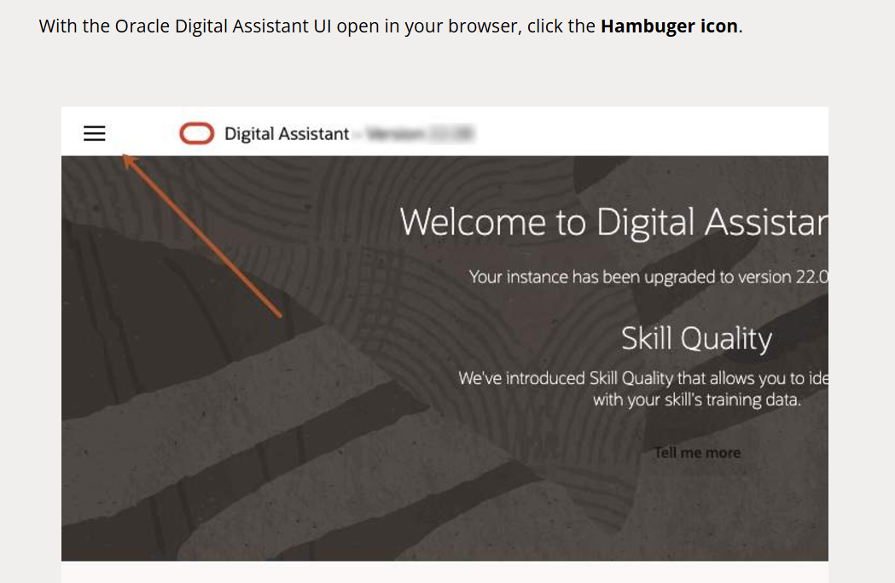

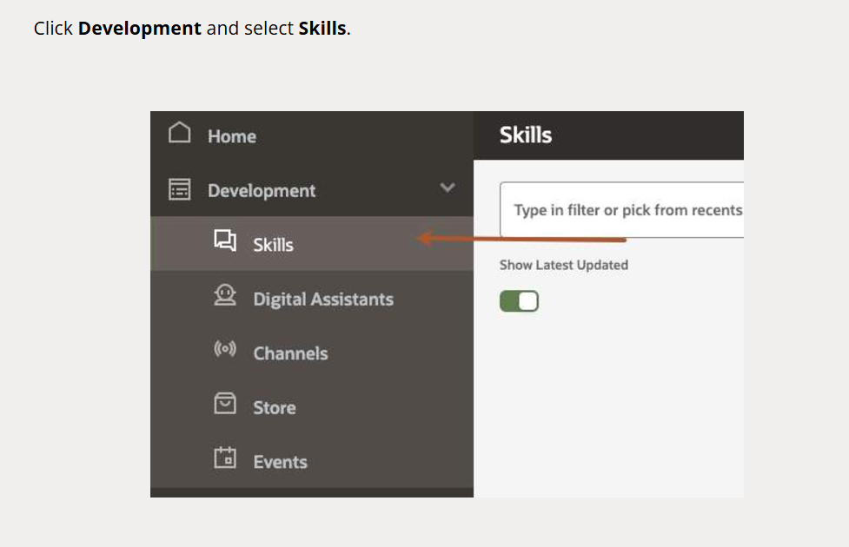

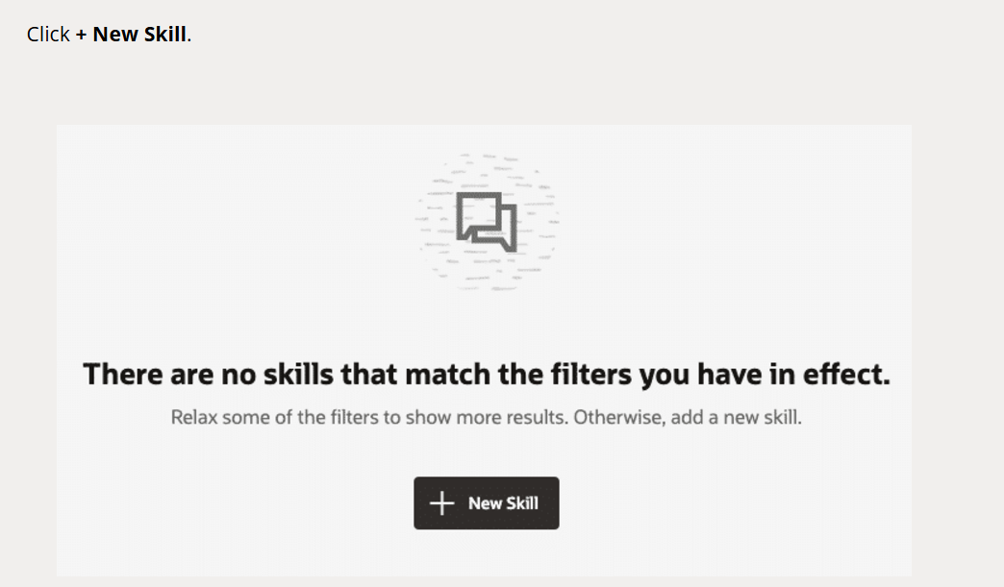

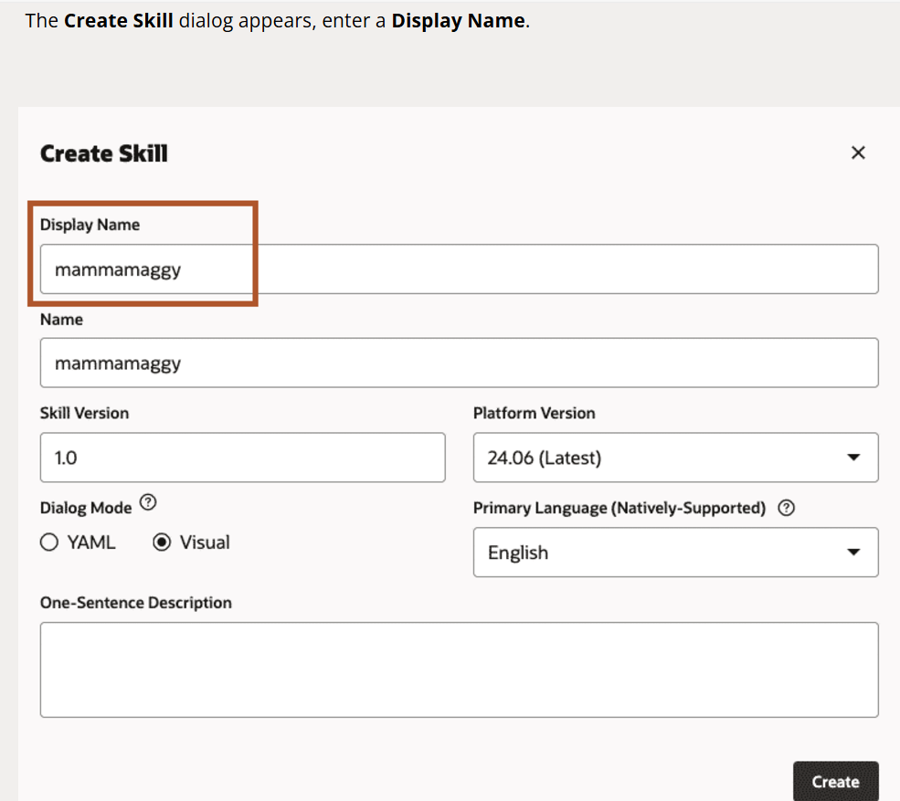

Here’s where we’ll begin to express the use case in terms of the concepts that support natural language processing (NLP). In the coming tasks, you will define intents and entities.

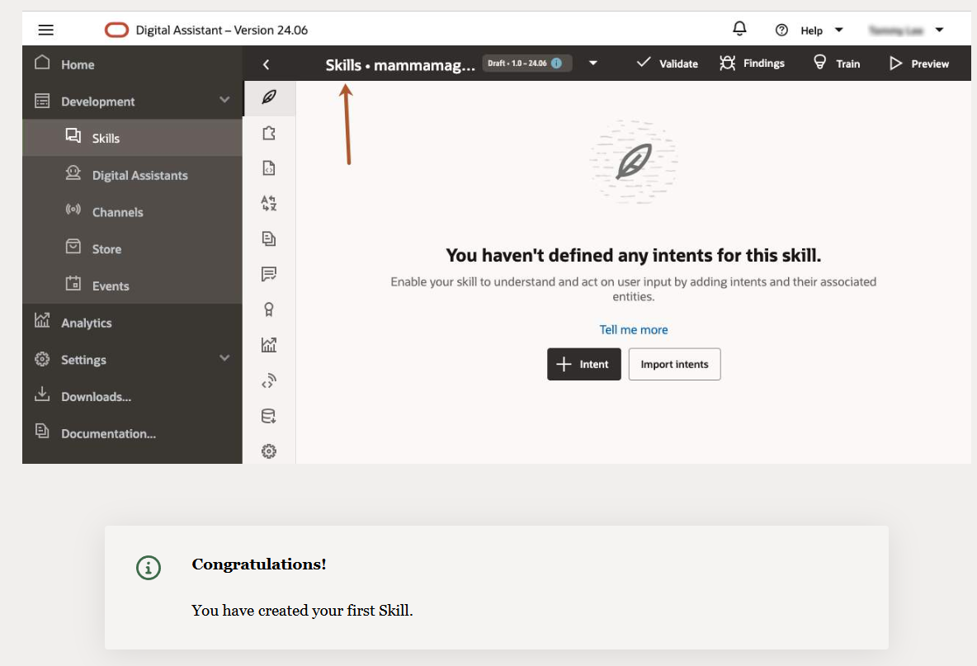

# Create Intents

Oracle Digital Assistant’s underlying natural language processing (NLP) engine doesn’t inherently know about the business or steps that a skill is supposed to do.

For the skill to understand what it should react to, you need to define **intents** and provide examples for how a user would request a specific intent. These examples are called **utterances**.

For example, if you want your skill to respond to a “Hello” message, you need to train it on the different variations of the same message:

* Hello
* Hi
* Howdy
* Hey
* What’s up

As the skill is trained, the engine will be able to automatically identify a Hello intent and deliver the expected welcome message.

For the Mama Maggy example, you will create intents for:

* Ordering pizza
* Cancelling an order
* Filing a complaint

Let's create the Order Pizza Intent.

In the left navigation bar for the designer, select Intent icon then **+ Intent**.

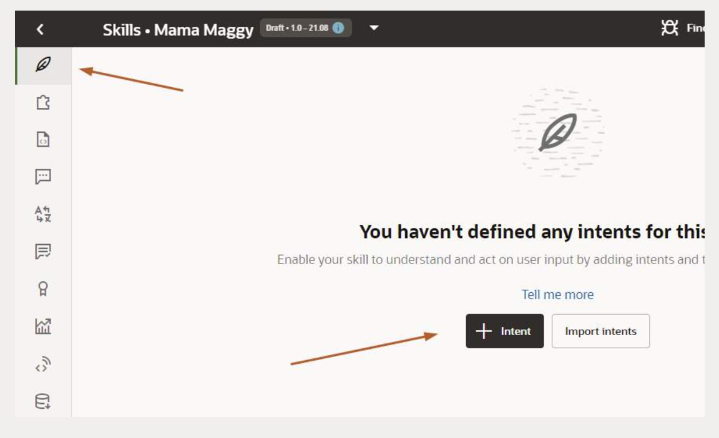

In **Conversation Name** field, click Edit and enter **OrderPizza**.

In the **Name** field, enter **OrderPizza**.

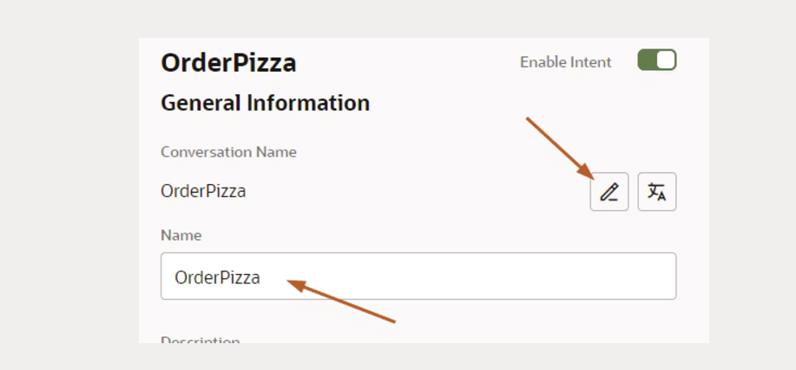

Open the **Advance input mode** to add the utterances.

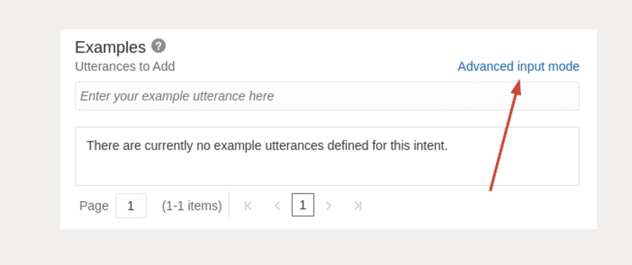

Copy the example sentences below then paste them into the **Utterances to add** field.

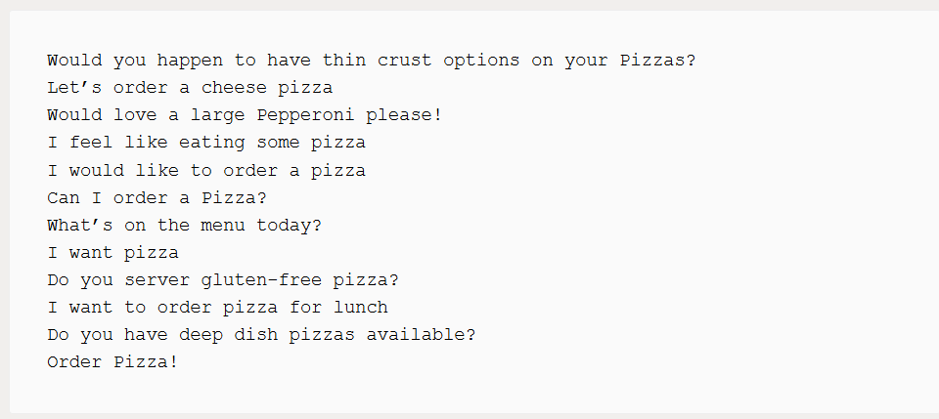

Click **Create** to continue.

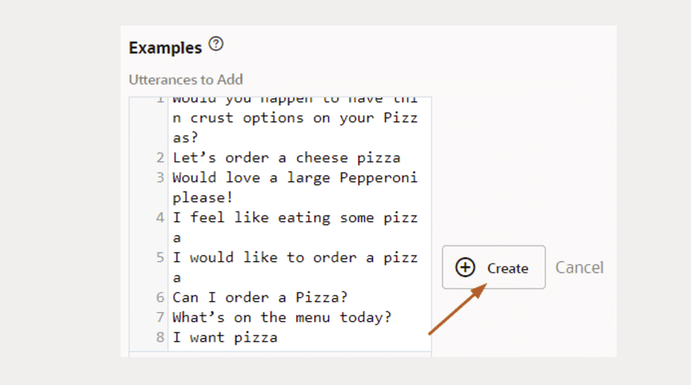

You’ll notice that it's fine for utterances to have inconsistent punctuation and capitalization

Click **+Add Intent** to create the Cancel Pizza Intent.

In the **Name** and **Conversation Name** field enter **CancelPizza.**

If required, click the **Advance input mode** to add the utterances.

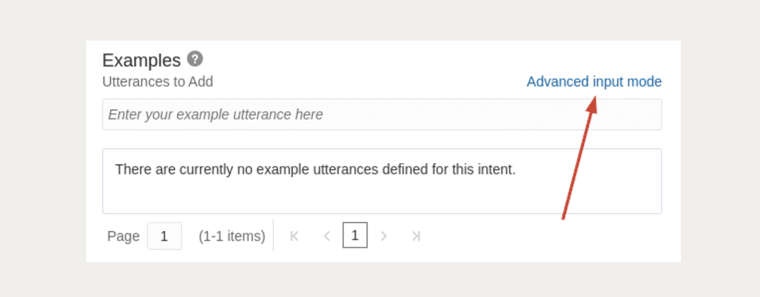

Copy the example sentences below, paste them into the **Utterances to add** field, and click **Create** when done.

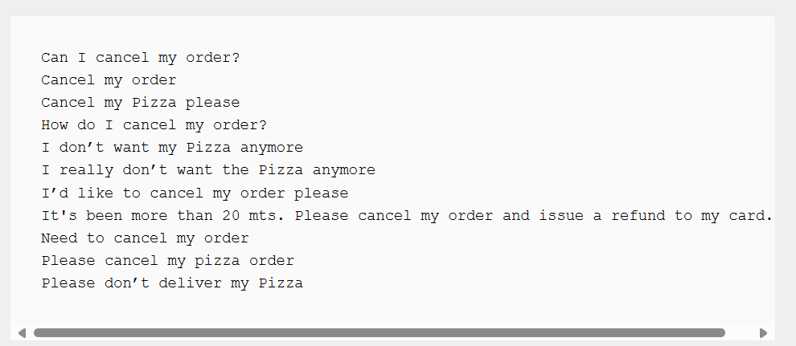

Click **+Add Intent** to create the File Complaint Intent.

In the **Name** and **Conversation Name** field, enter **FileComplaint.**

Copy the example sentences below, paste them into the **Utterances to add** field, and click **Create** when done.

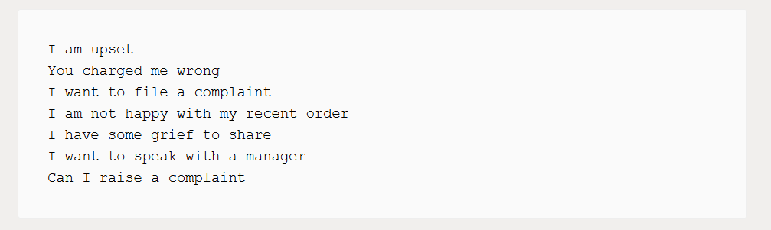

Your screen should now look similar to what is shown here.

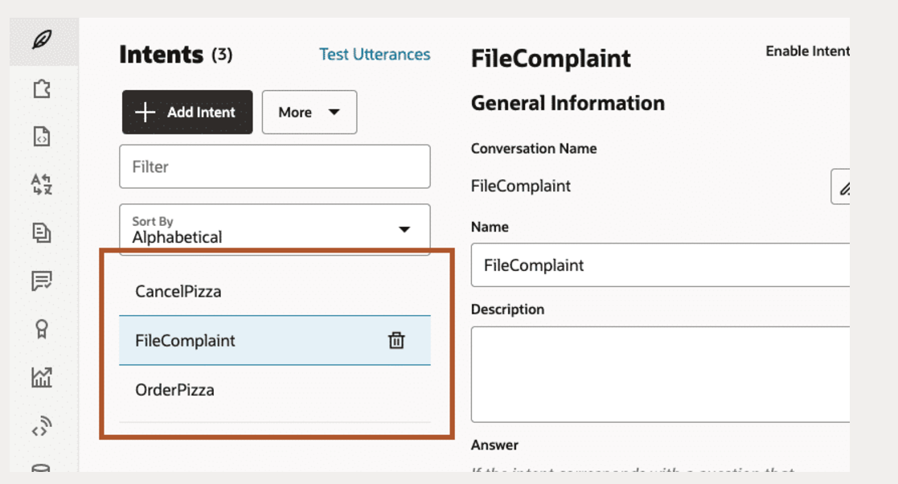

You’ve now provided the basic ingredients that allow the skill to recognize user inputs for ordering a pizza, but right now the skill has no cognition. It can’t understand any user input.

To enable it to understand the intents, you need to train it.

Locate the **Train** **button** on the right side of the page.

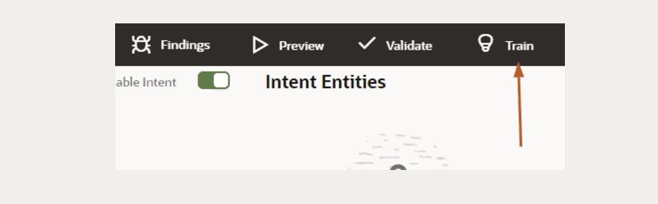

Select **Trainer Ht**, a linguist-based model, and click **Submit**. Wait a few seconds while the training completes.

## What is the difference between trainer HT and trainer TM?

* **Trainer HT** uses a linguistic approach that is based on understanding of language and how it's structured.
* **Trainer TM** uses a machine learning approach that is based on text analysis and on statistical and mathematical models to make predictions.

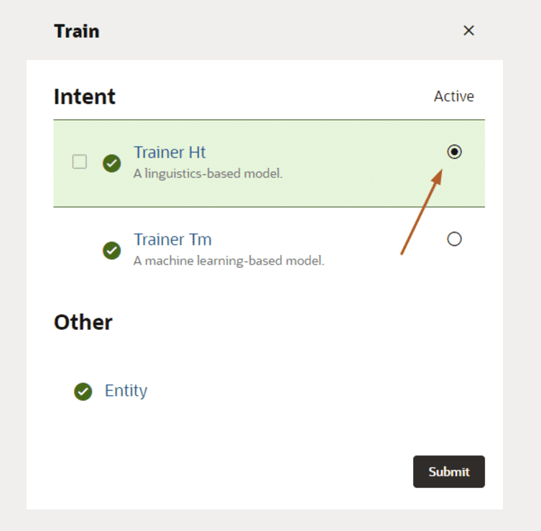

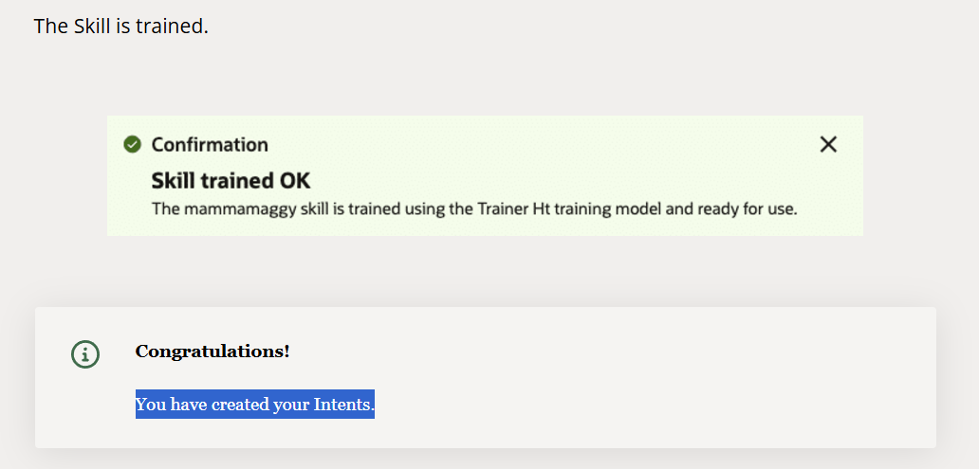

# Test your Model

Good intent models are created in an iterative cycle of training, testing, retraining, and retesting.

A good intent model is one where the different intents are clearly defined and easily distinguishable from one another, minimizing the potential for confusion or misclassification.

**Below is an example of an intent model with higher ambiguity (confusion) between intents.**

Notice the trigger phrase **"I want to book a flight"** is in both intenst,**"Book Trip"**and **"Book Flight"**. This can create ambiguity, as the model may have difficulty distinguishing whether the user wants to book a trip or just a flight.

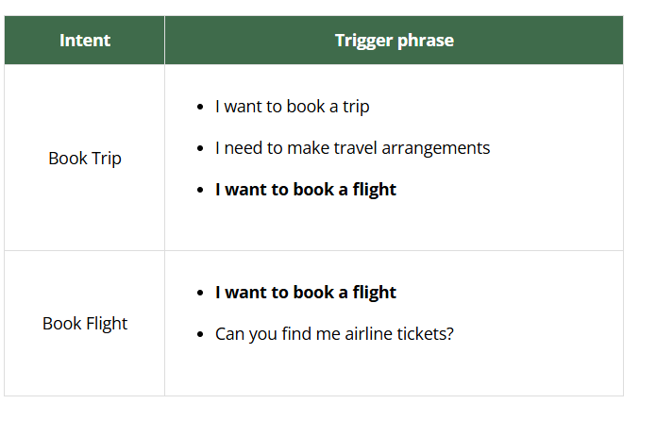

Click the intent option and select **OrderPizza**.

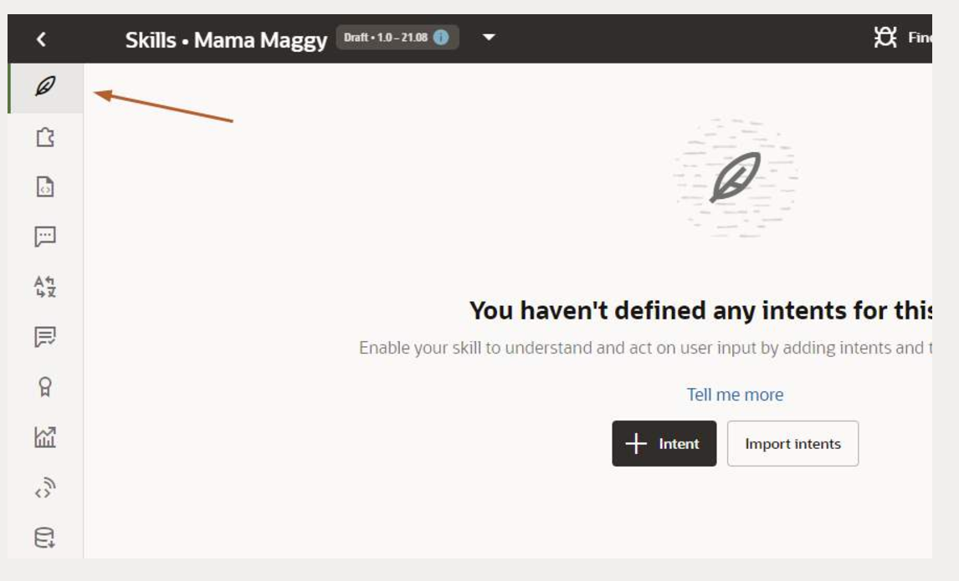

Click the **Test Utterances**.

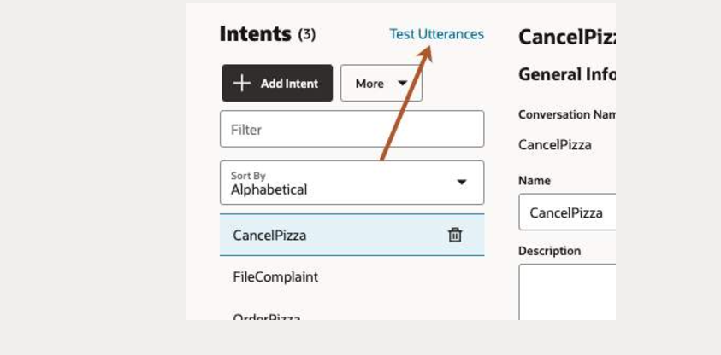

When the **Utterance Tester** dialog appears, in the **Utterance** box enter the following sentence.

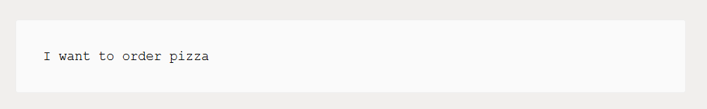

When ready, press **enter**.

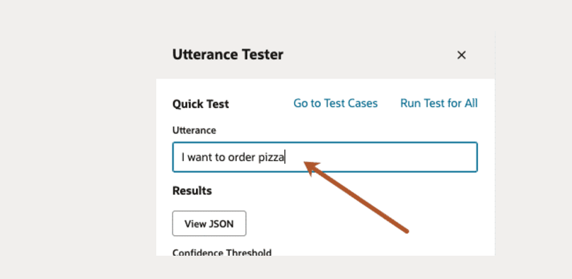

What are theIntent matches and the **Intent confidence level**?

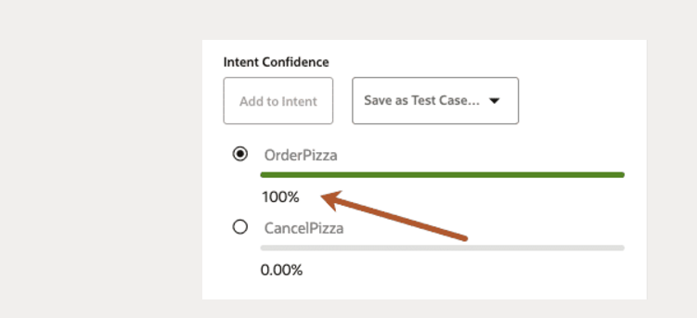

Next, try the following sentence:

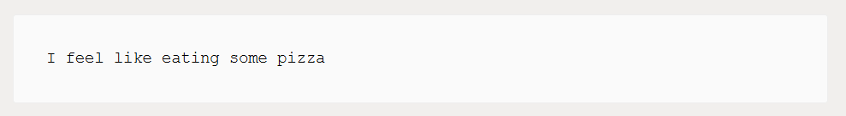

This should also resolve to the **OrderPizza** intent.

Now, try the following sentence:

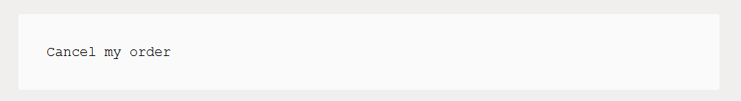

This should resolve to the **CancelPizza** intent.

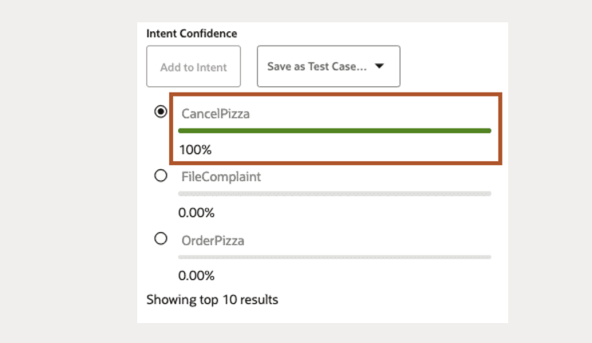

And now try this

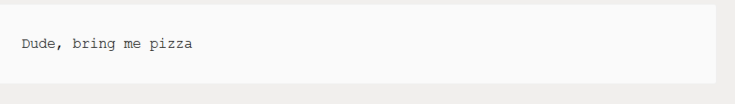

See what that resolves to.

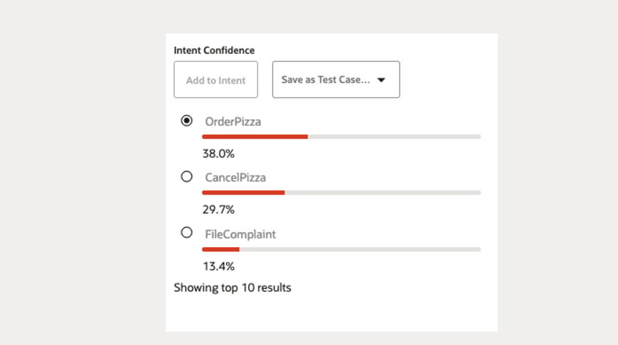

As you can see, the intent engine is (correctly) most confident that the user wants to create an order, but not by a particularly high margin.

The sentence "Dude, bring me pizza" deserves a higher confidence score, so we should add it to the list of utterances.

Close the Tester dialog.

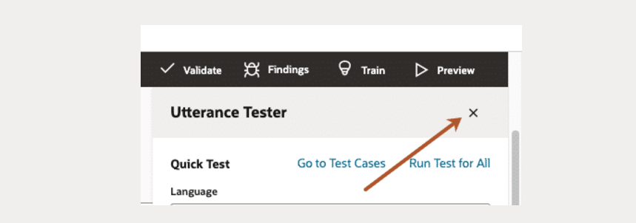

Add it to **Examples**. Don't forget to click **Create**.

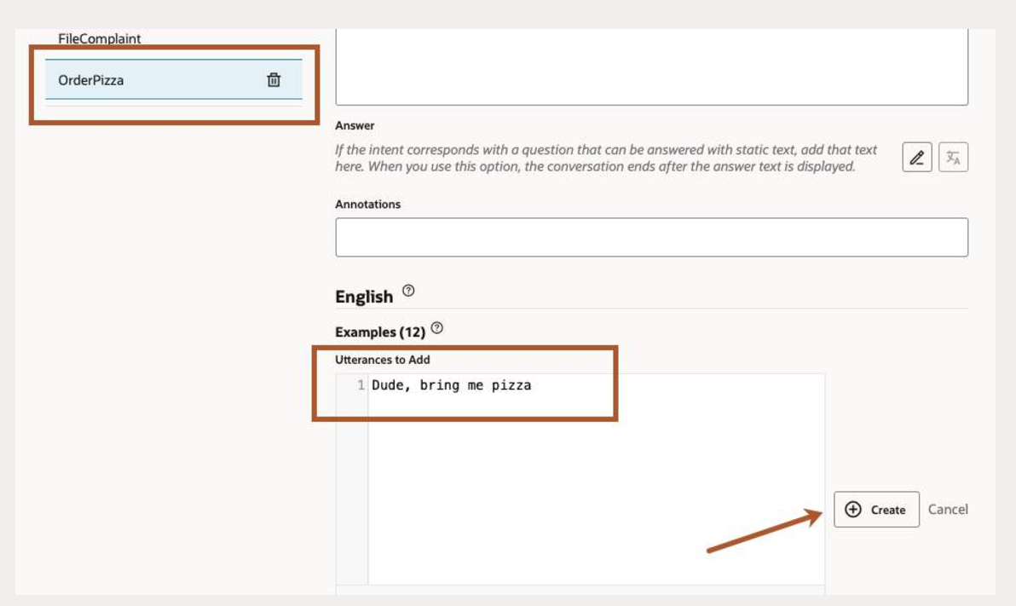

Click **Train** to retrain the model using **Trainer Ht** option

Again, click **Test Utterances ⮕ Utterance ⮕**enter the following and press enter:

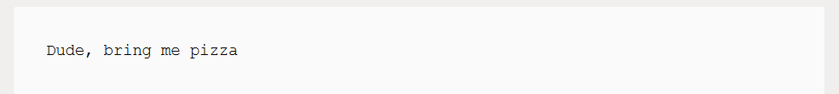

The confidence score should be much higher for **OrderPizza** (possibly even 100%).

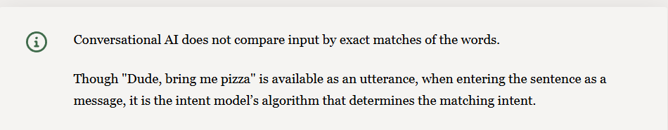

Type the following.

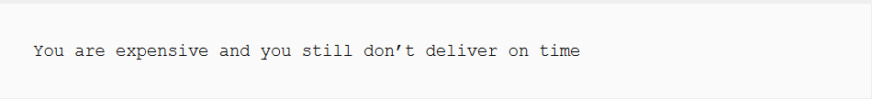

Here is the possible output of intent matches.

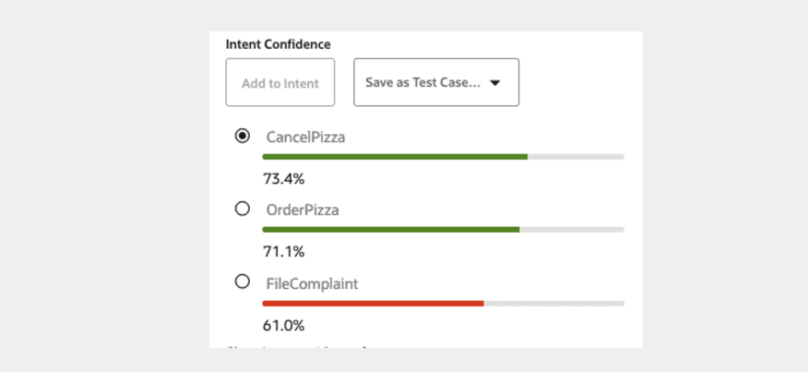

In all likelihood, the **FileComplaint** intent did not receive the highest score. In the above screenshot, CancelPizza "won" though it’s also possible that OrderPizza could get the highest score.

To help remedy this, close the **Tester** dialog and, in the **FileComplaint** intent, add it to **Examples** and press **Enter**.

Shown here, the utterance is added to the intent.

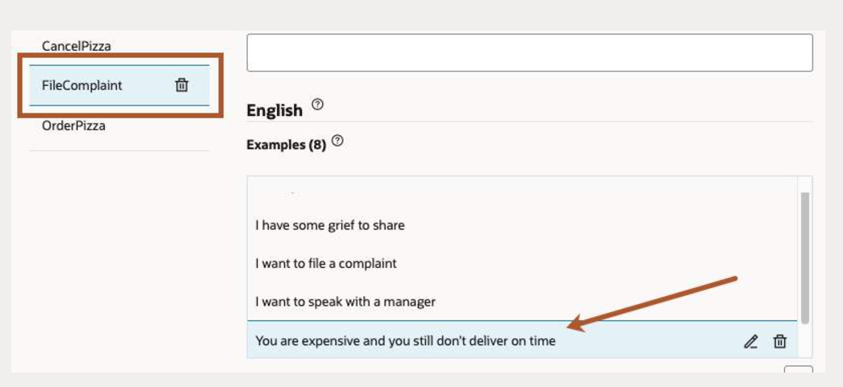

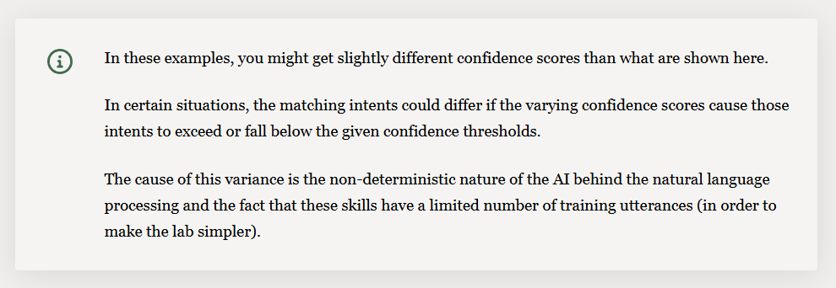

For us humans, it is easy to see that **"You are expensive and you still don’t deliver on time"** is not an order but a complaint.

However, a skill first needs to be trained before it is able to gain the same understanding. The NLP model in this exercise is not trained with a lot of data, so it’s more likely to make mistakes.

Click **Train** again to retrain the skill.

Think of two or three more phrases that the system might have problems matching to an intent with high confidence and try them in the Intent tester.

If you find one that doesn’t match well, select the intent that it should be resolved to and add to Examples.

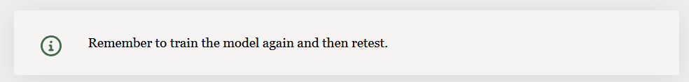

**Notes on what you just did**

In this part of the lab, you have tested the quality of your intent training with the goal being to ensure a high level of confidence when resolving intents.

In a real skill project, you would always need to go back to the intent testing with user-provided entries you find in the conversation logs.

If, using that test input, your intents are not matched the way they should be, you need to add them as example utterances to proper intents and then retrain the model.

Oracle Digital Assistant also has a batch mode that allows you to test based on a log of a previous set of tests. This is useful for rerunning a set of tests iteratively as you fine-tune your intents.

# Create Entities

Now it’s time to add **entities**, which detect information in the user input that can help the intent fulfil a user request. Such information could be the size of pizza, the toppings of pizza, and delivery time.

For example, the user input **"I’d like to order a small meaty pizza at 9:00 pm"**contains all three of these information types.

We’ll create custom **entities** for size and topping and later use a built-in entity for time. While we’re at it, we’ll add some synonyms (including some common misspellings) that optimize the entity’s ability to tag words from sloppy user input.

In the left navigation for the designer, click the **Entity** **icon ⮕** **+ Entity** to create a new entity.

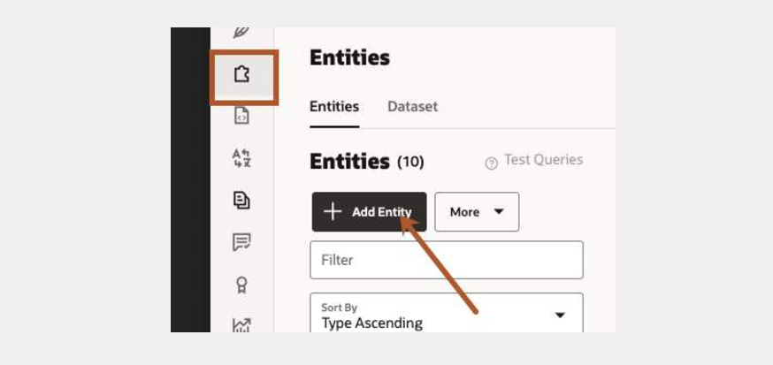

In the **Name** field, enter **PizzaSize**. For Type, select **Value List.**Thenclick the **+ Value** button.

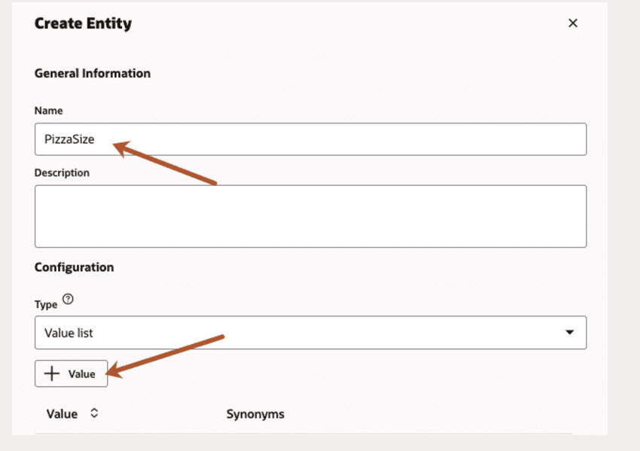

1. For **Value**, enter **Small**.
2. For **Synonyms**, enter **Personal**, press Tab, enter **smallest,** and click **Create**.

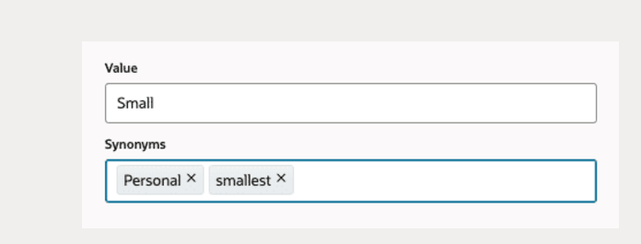

The screen should look something like this.

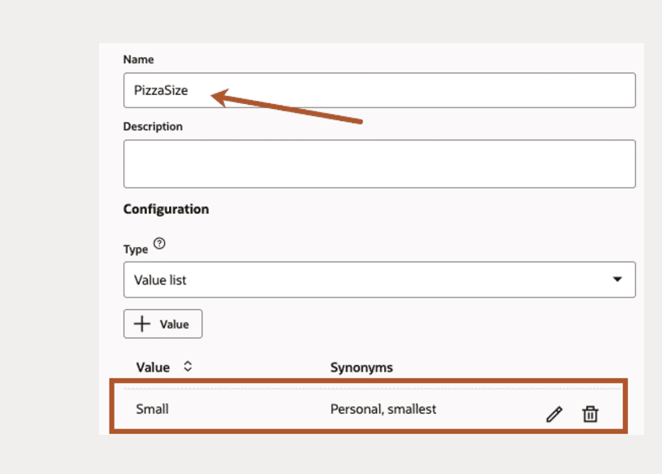

Following the previous steps, create the following values:

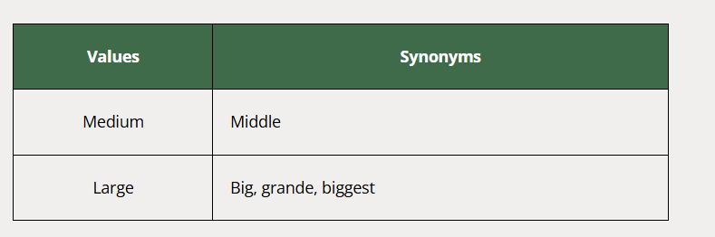

Your screen should look something like this:

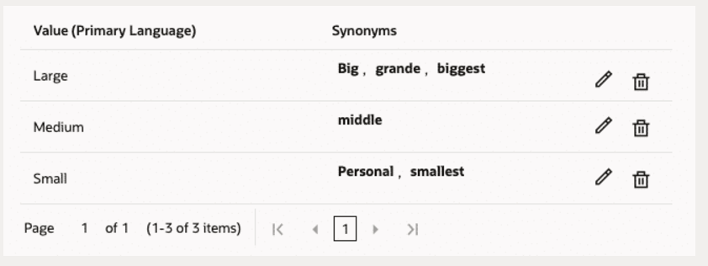

Click **+ Add Entity** to create the**PizzaTopping** entity.

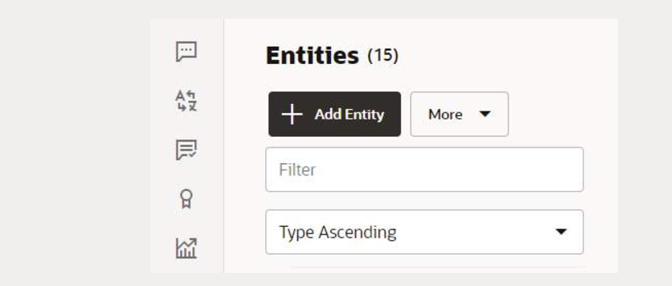

1. In the Name field, change the value to **PizzaTopping**.
2. Add values for **Meaty**, **Veggie**, **Hot and Spicy**, and **American Hot**.

Your list of **PizzaTopping** entities should look like this here:

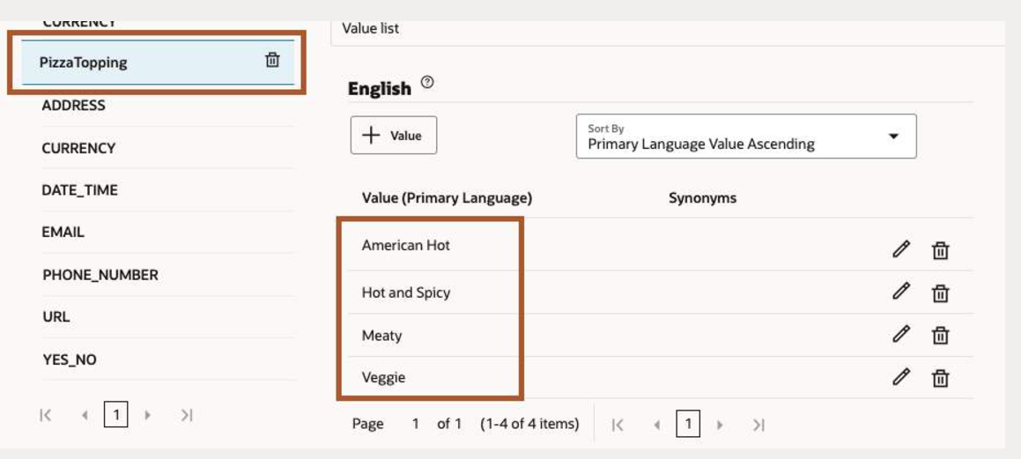

Click **+ Add Entity** to create a **composite bag entity**.

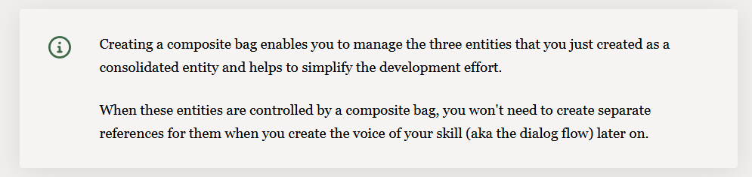

In the Name field, enter **cbePizza**, in the Configuration section, select Composite Bag from the **Type** dropdown.

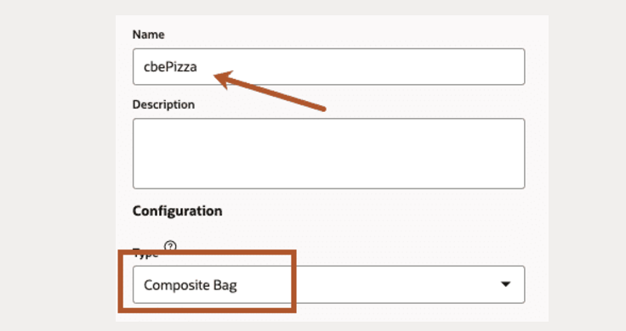

Select **cbePizza** and click **+ Bag Item**.

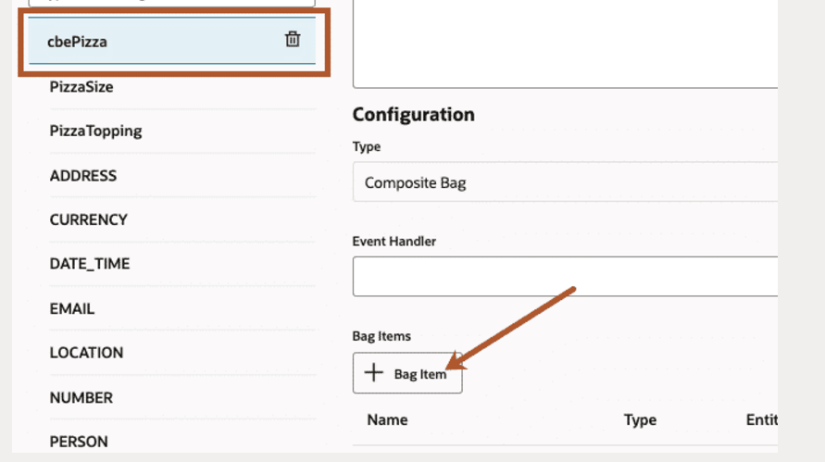

In the **Add Bag Item** dialog,

1. Enter **pizzaSize** as the name.
2. Select the type to be **Entity**.
3. Choose **PizzaSize** from the **Entity Name** list.

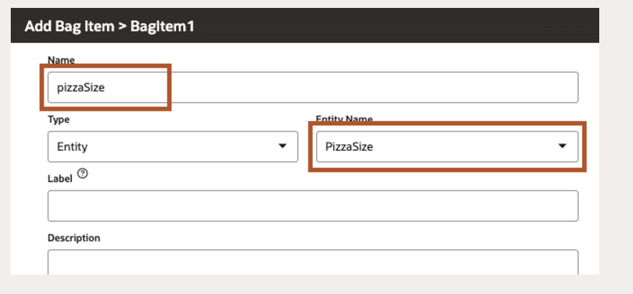

Scroll down the page, click the **edit icon,**and replace the prompt "Please enter PizzaSize" with the following:

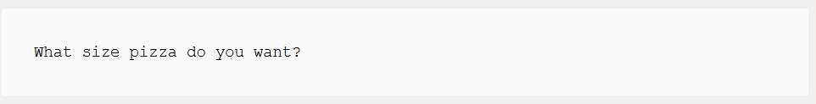

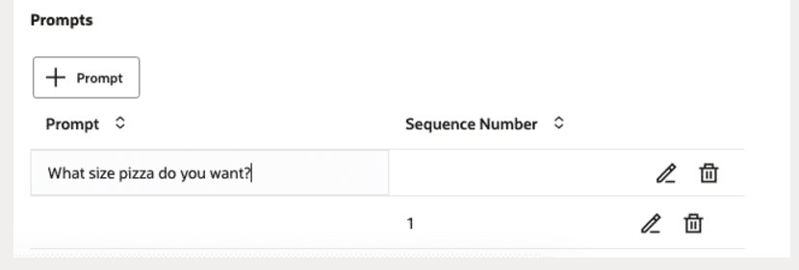

Click **Close** (located at the upper right) when you are done.

Repeat for the **PizzaTopping** entity.

1. Enter **pizzaTopping**in the name box.
2. Select **Entity** as the type.
3. Choose **PizzaTopping** from the **Entity Name** list.
4. Scroll down the page, click **+ Prompt,** and replace the prompt with the following:

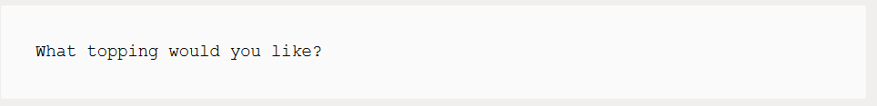

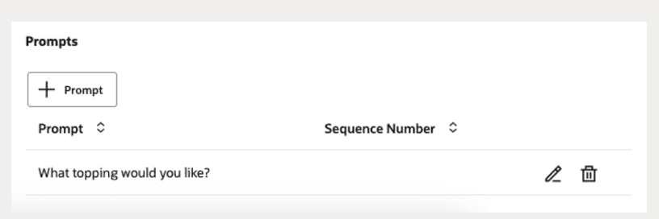

In addition to enabling users to select the pizza type and size, the skill will also enable them to enter a delivery time.

For this, you're going to add another entity item to the bag. Unlike the **PizzaSize** and **PizzaType** entities that you created from scratch, you're instead going to use the built-in **DATE_TIME** entity, which recognizes various time formats in the user input

To create this item:

1. Click **cbePizza**  **⮕** **+Bag Item**.
2. Enter **deliveryTime**as the **Name**.
3. Select **Entity** from the **Type** list.
4. Choose **DATE_TIME** from the **Entity Name List**.
5. Choose **TIME** from the **Subtype** dropdown.

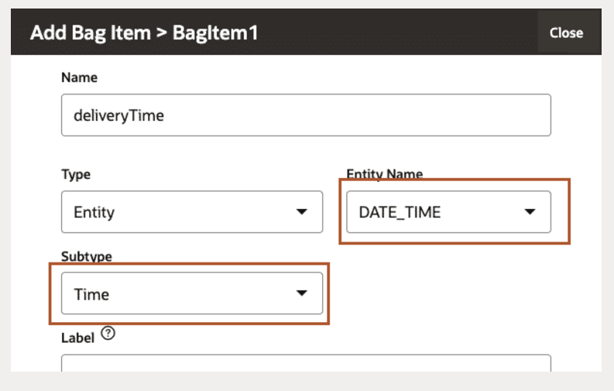

Scroll down the page, click **+ Prompt**, and enter the following; don't forget to press enter.

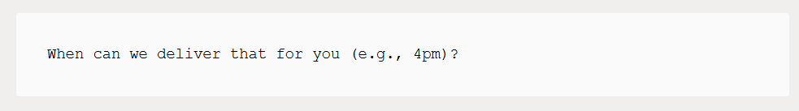

Click **Close** when you are done.

The Bag Items section of the **cbePizza** editing page should look like this here. The items names are case sensitive.

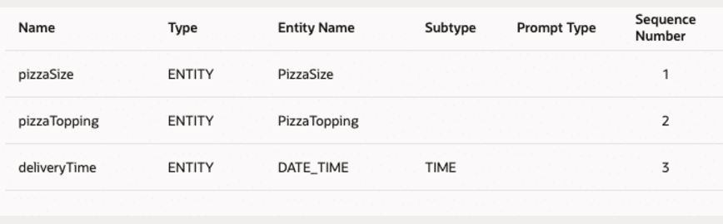

Associate our entities with the appropriate intents.

For an entity to be recognized when parsing the user input message, it needs to be associated with an intent.

In the left navigation for the designer, select intent

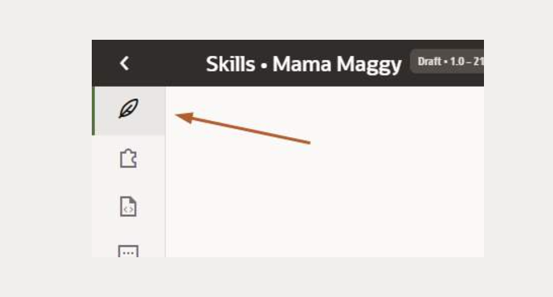

Select the OrderPizza intent and click **+ Entity** (in the right side of the page shown below).

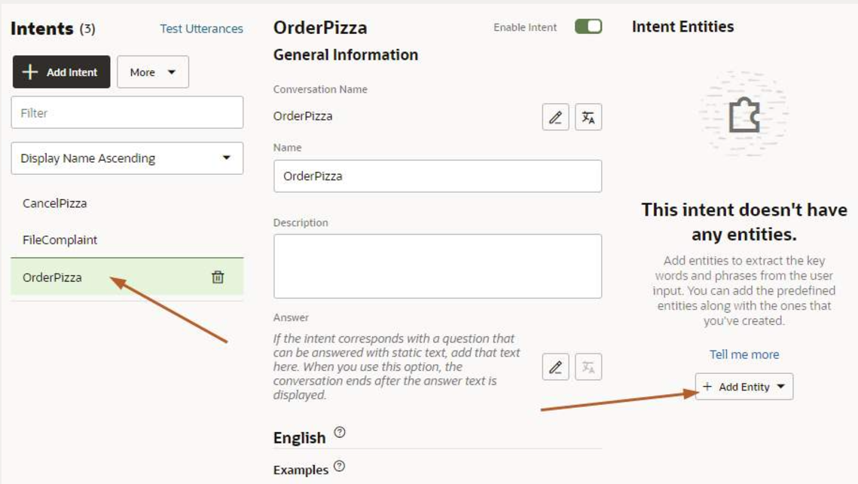

Select the **cbePizza** entity.

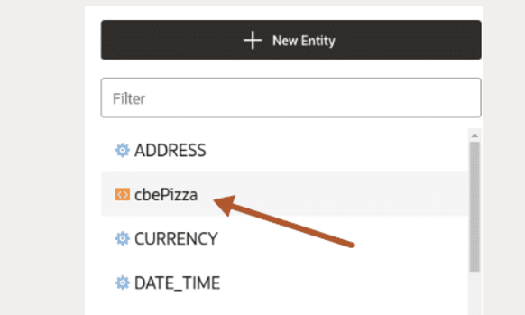

The cbePizza entity is selected.

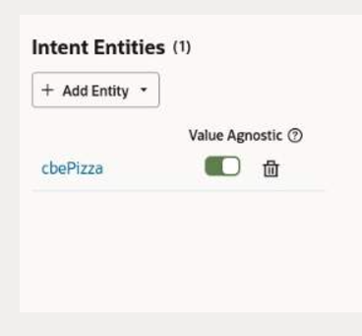

Retrain the model by clicking **Train**.

TheTest Utterances feature enables you to test whether the skill identifies entity values in user input.

In the left navigation for the designer, select **Intents** and click **Test Utterances**.

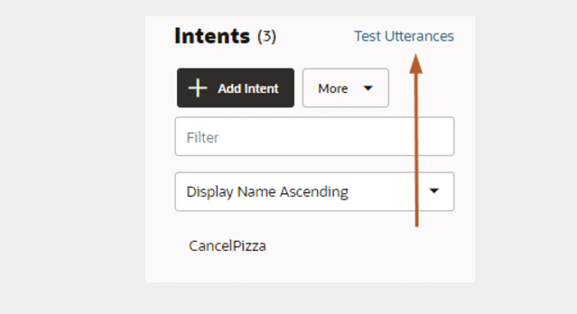

In the Utterance box, copy and paste the following and **ENTER** to test.

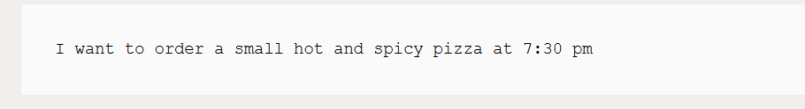

Scroll down to view the results in **Label View**, click **List View** to show the result in a table format.

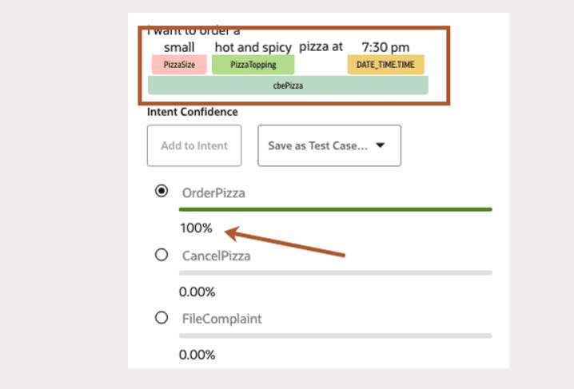

Now let’s try another one. In the **Utterance** **box**, enter the following and **ENTER** to test.

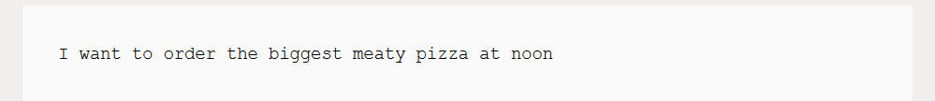

Click **List View** you will observe the **PizzaSize** entity shows the right value for the biggest synonym. Also, **noon** is properly interpreted as 12 p.m.

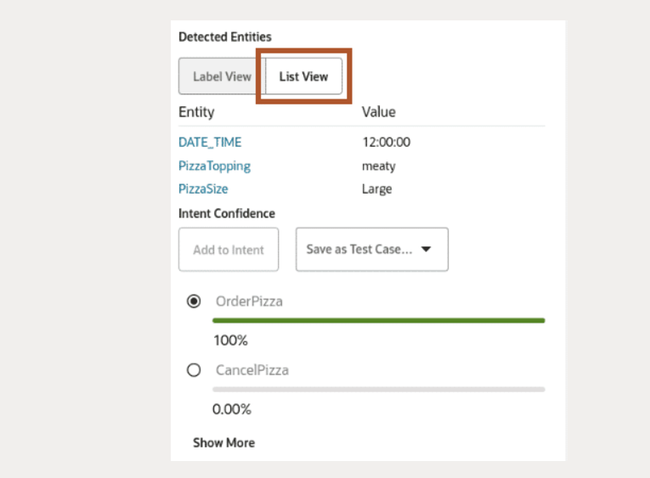

You have created custom entities for the **OrderPizza** intent, associated the entities with the intent, and tested the entity recognition in the embedded skill tester.

Similar to the **PizzaOrder** intent, you would typically need to create and associate entities for the other intents as well. In the interest of time, this tutorial only focuses on the **PizzaOrder** intent.

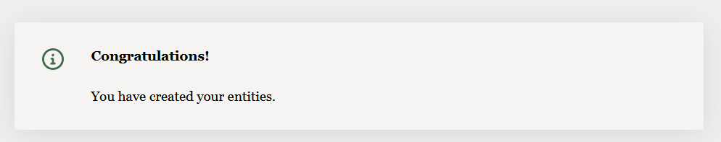

# Design the Dialog Flow

With the natural language processing (NLP) model created, you are ready to build the **dialog flow** for the skill. The **dialog flow** is a conversation blueprint that defines interactions users may have with the skill.

Each interaction is defined as a state. Each state references a component, which renders a skill response, receives user input, sets and resets variables, resolves user intents, or authenticates users.

Now that you have the OrderPizza intent and the pizza variable, you're ready to start building the dialog flow.

Click the **Flows** icon.

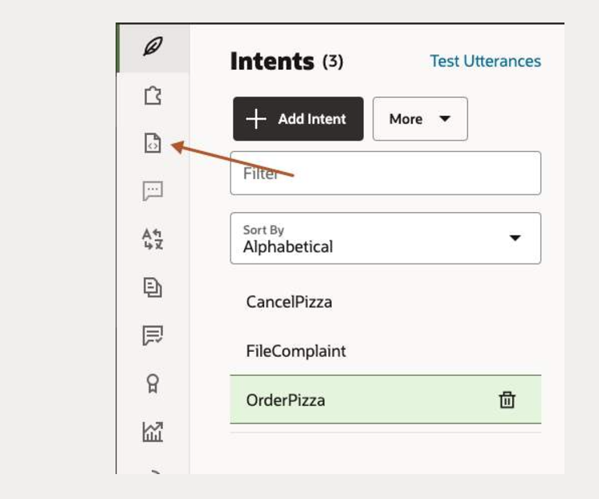

Click Add Flow

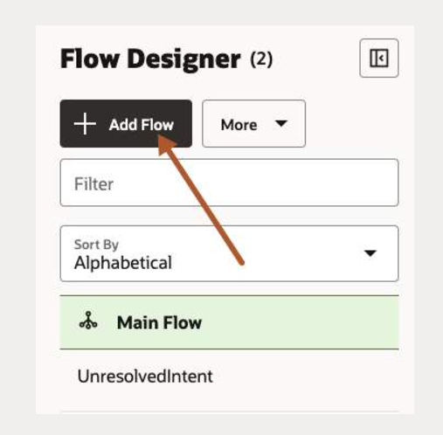

In the Create Flow dialog, enter the name as **intent.reg.order**.

Select **OrderPizza** from the **Intent Name** list to create a mapping between the **OrderPizza** intent and this flow.

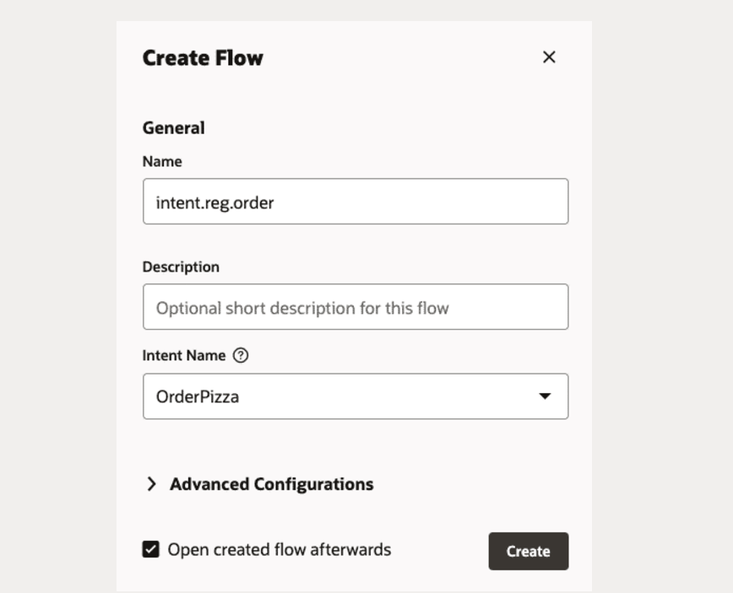

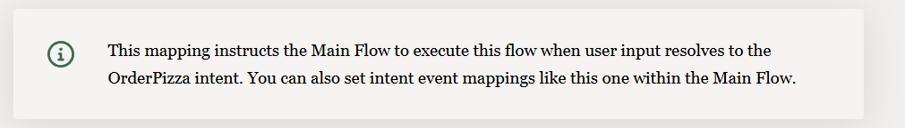

In the dialog flow editor, click the **option icon "..."** on the **Start** node and **Add a start state**

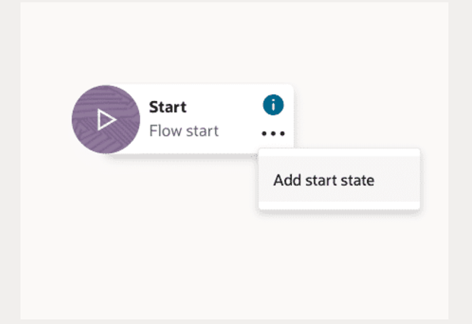

In the Add State dialog,

1. Choose **Send Message** template.
2. Enter the name as **startOrderPizza**.
3. Enter the description as **Greeting Message**.
4. Click **Insert** when done.

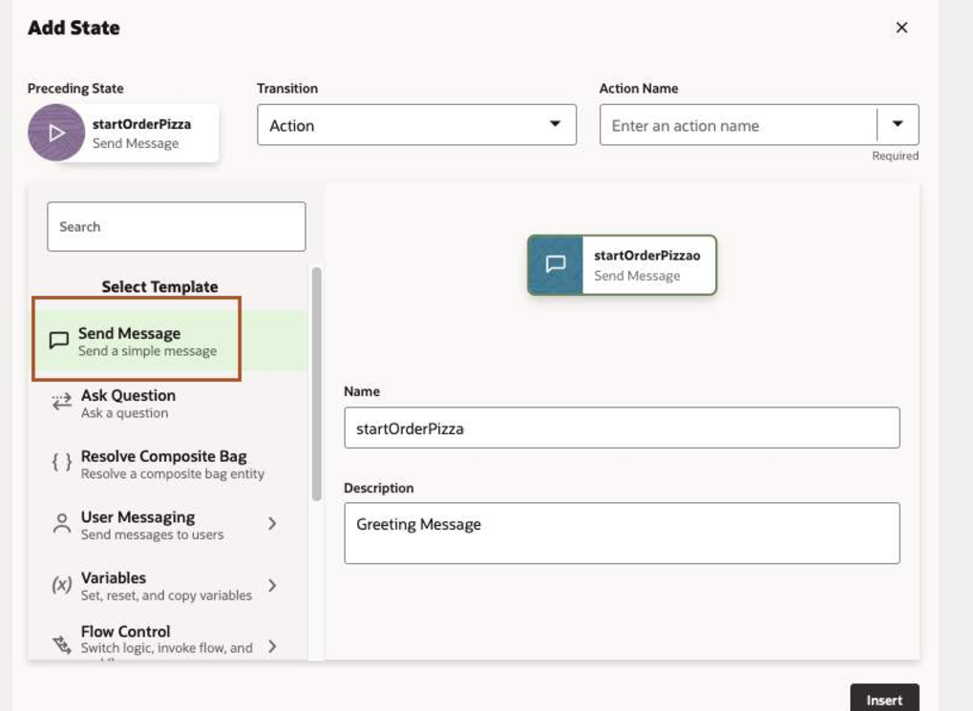

When you're done, the **startOrderPizza** state should appear in the canvas with its property editor open to the Component page.

Enter the following.

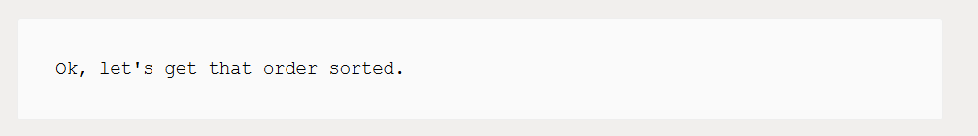

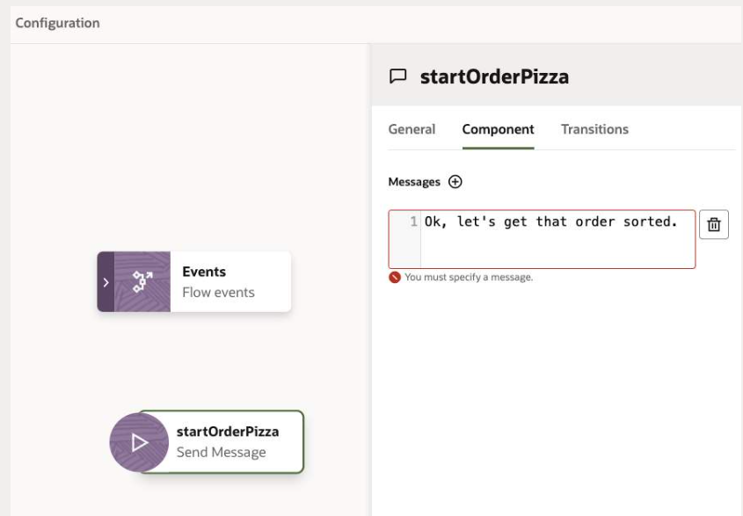

Click the **option icon** "..." on the **startOrderPizza** node and click **Add state**.

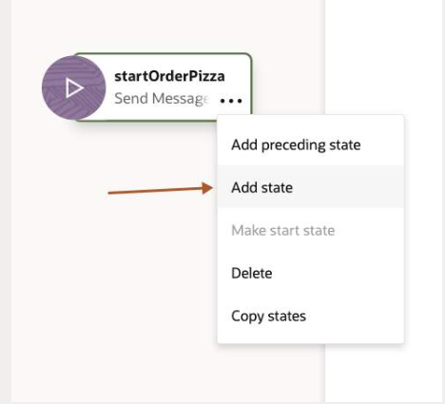

In the Add State dialog:

1. Choose Resolve Composite Bag template.
2. Enter the name as **resolve_cbePizza.**
3. Enter the description as **Pizza menu.**
4. Click **Insert** when done.

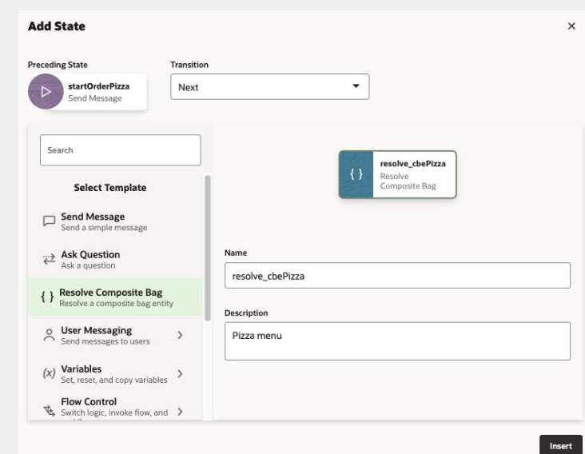

When you're done, the **resolve_cbePizza** state should appear in the canvas with its property editor open to the Components page.

**Note the next transition line that connects it to the startOrderPizza stat**

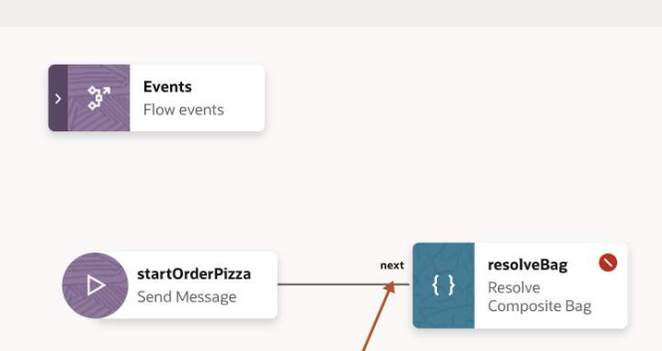

Like the **startOrderPizza** state, the **resolve_cbePizza** state is flagged with an error because of an undefined property.

For this state, the Component page tells you that you can fix this error by adding a variable reference a composite bag entity, which in this case is the cbePizza entity

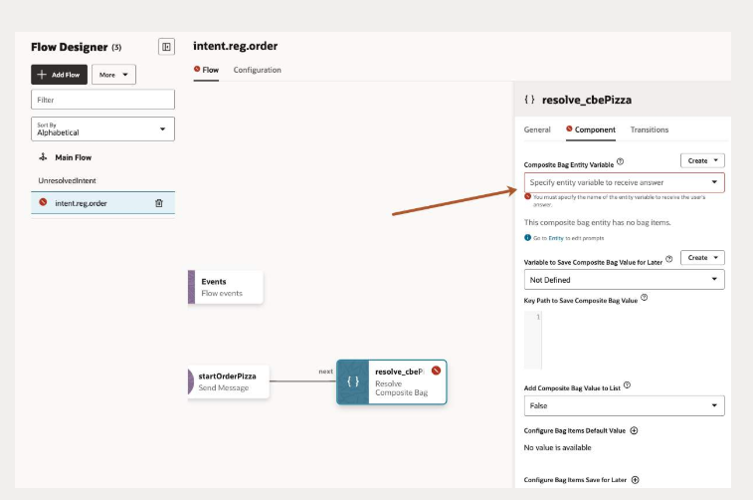

To create this variable, click **Create ⮕ Flow Scope Variable**

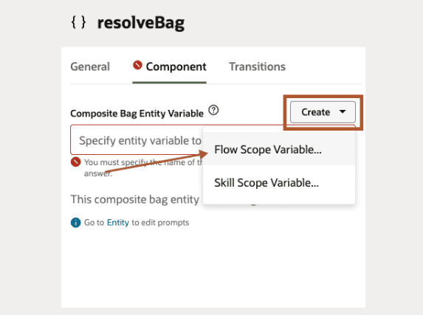

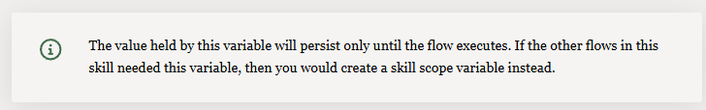

In the create flow variable dialog, enter the name **pizza**.

Enter the description as:

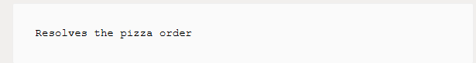

Select **Entity** as the variable type, then select **cbePizza** as the entity name.

Click **Apply**

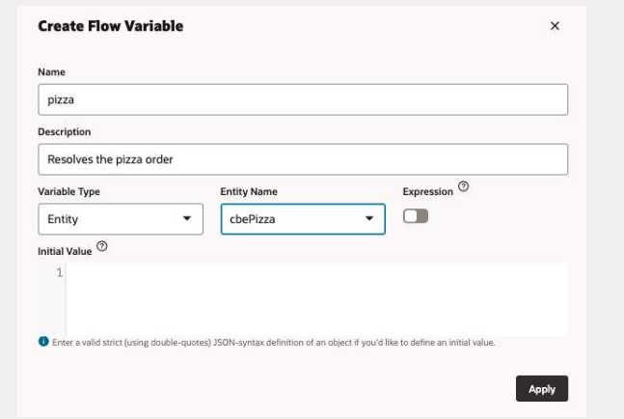

The composite bag entity variable **pizza** created.

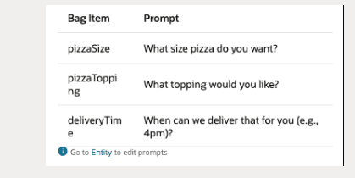

Click **resolve_cbePizza** node and click **Add state**.

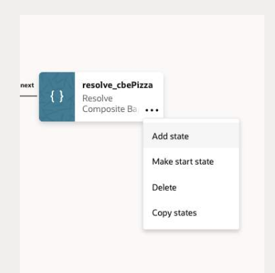

In the add state dialog, select **Send Message** template.

Enter the name as

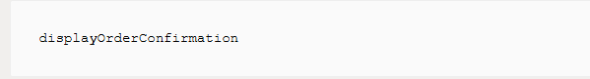

Enter the description as:

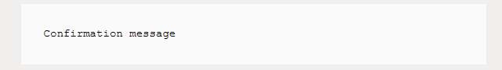

Click Insert when done.

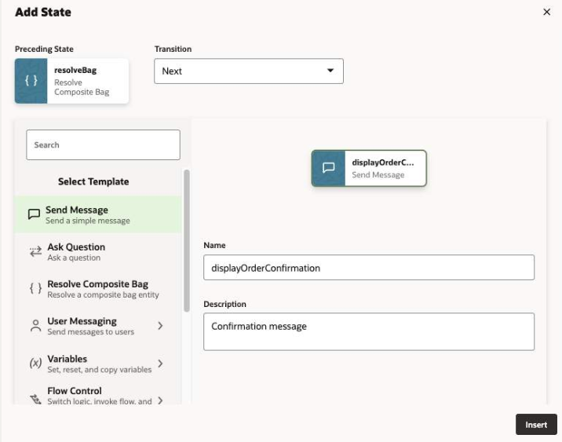

In the Component page of the property inspector, enter the following confirmation message.

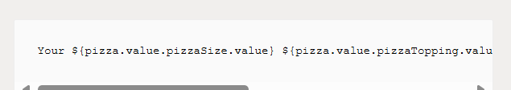

Ref- Your ${pizza.value.pizzaSize.value} ${pizza.value.pizzaTopping.value} pizza will be delivered at ${pizza.value.deliveryTime.value[0..4]}.

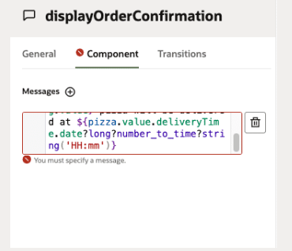

Click the canvas. Your flow should look like this.

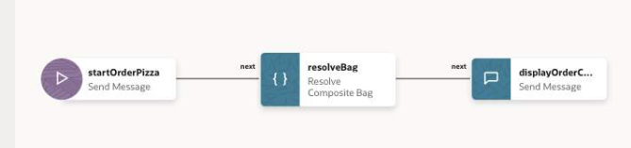

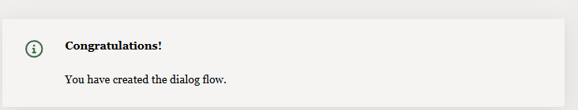

# Test your Skill

Now that all of the skill’s pieces are in place, let's test its behavior.

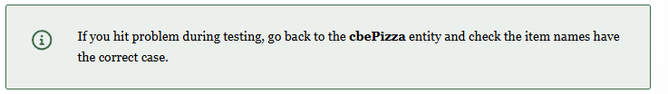

Open the **Conversation Tester** by clicking **Preview**.

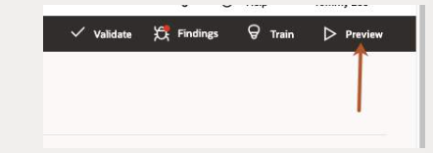

Enter the following

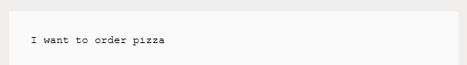

You should see a menu of pizza sizes

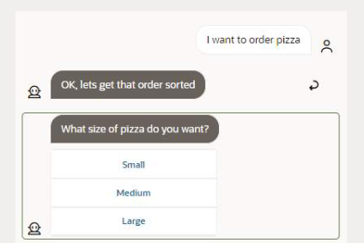

In the pizza size menu, select an option, e.g, **Small**.

Select a topping e.g, **Veggie.**

Enter a delivery time, e.g, **7:30 p.m**.

You should receive an order confirmation similar to the one shown in the image below:

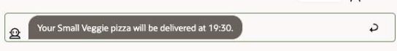

Click **Reset** and try another.

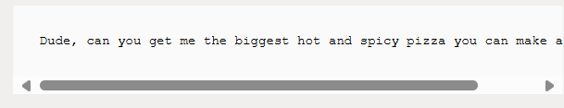

EX : Dude, can you get me the biggest hot and spicy pizza you can make at noon

This time, you should be immediately presented with the results of the order.

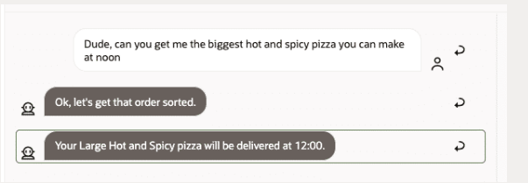

Finally, click **Reset**, enter the following:

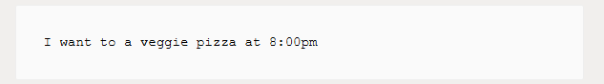

This time the topping menu and the delivery time should be skipped, but the pizza size list should be displayed.

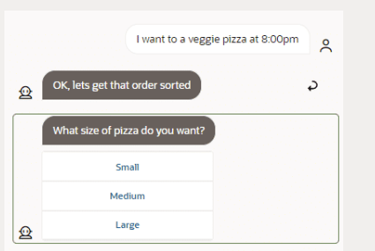

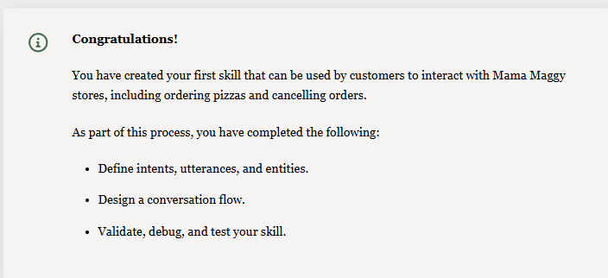

# Integrate your Digital Assistant with a Visual Builder app

**This is an optional bonus task...**

For this task you will use the Oracle Native SDK for Web/JavaScript (also known as Oracle Web SDK) to add to your website a chat window that communicates with an Oracle Digital Assistant skill.

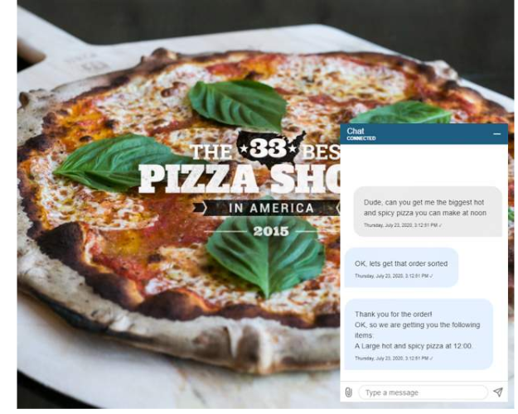

The SDK's features include configurable components, such as:

* Timestamp display
* Chat bubble size and padding
* Font color and size
* Custom buttons and icons
* Chat widget size
* Autocompletion of text
* JWT client authentication

The SDK connects to the Oracle Chat Server, which stands between Oracle Digital Assistant and the Skill. The chat server then passes messages to the skill for processing and delivers the skill's response to the client

Let's deploy a **Visual Builder** instance by going back to the **OCI Console**homepage

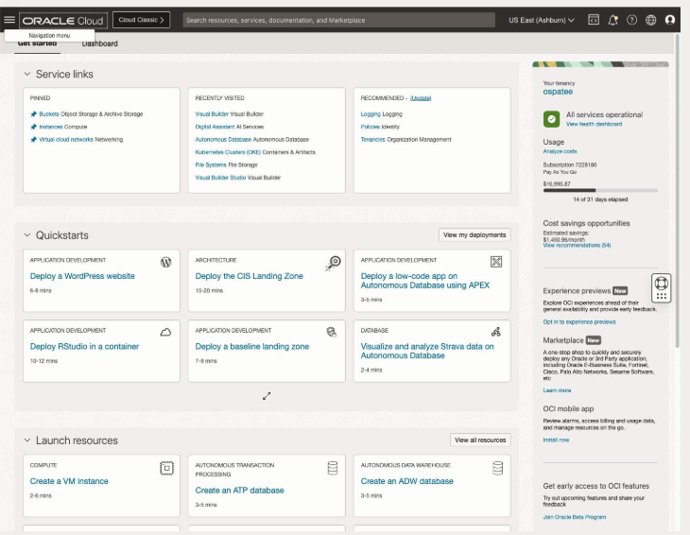

Click the **Hambuger icon ⮕ Developer Service ⮕ Visual Builder**.

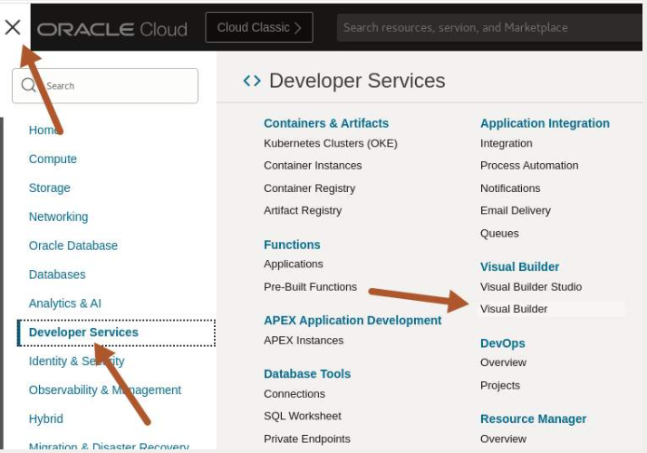

Skip to step 5 if you already have a Visual Builder instance.

Click **Create instance**.

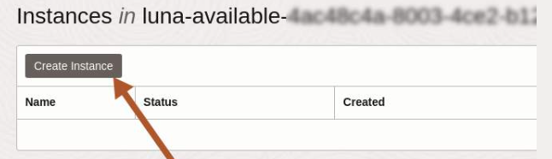

Enter a name for your instance and click **Create Visual Builder Instance**

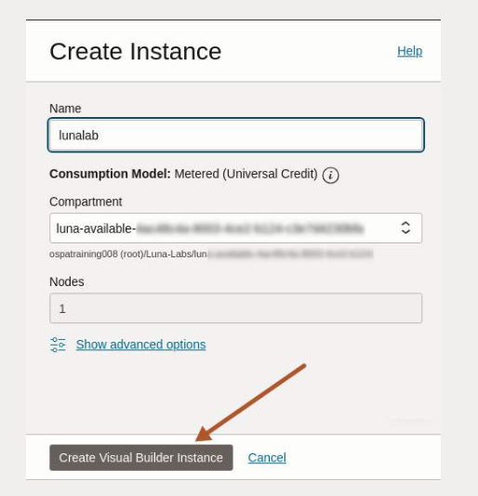

The instance has the status **Creating**.

The Visual Builder will take around three minutes to complete. Let's continue with the lab and check the staus later.

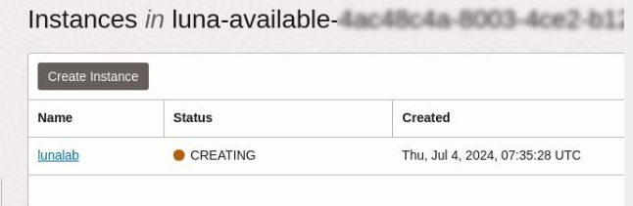

Go back to ODA through the **OCI Console**homepage.

Click the **Hambuger icon ⮕ Analytics & AI ⮕ Digital Assistant**

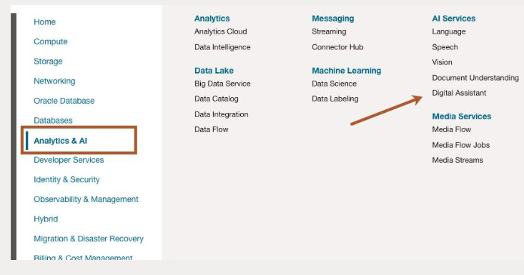

Click the **option icon** **⮕ Service Console.**

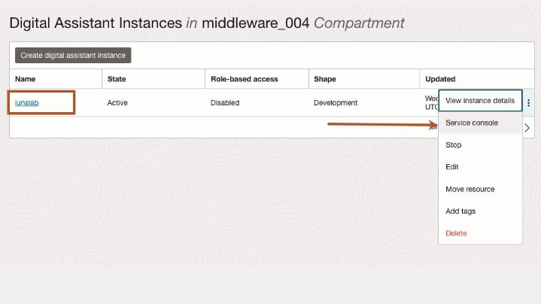

Select your digital assistant created earlier

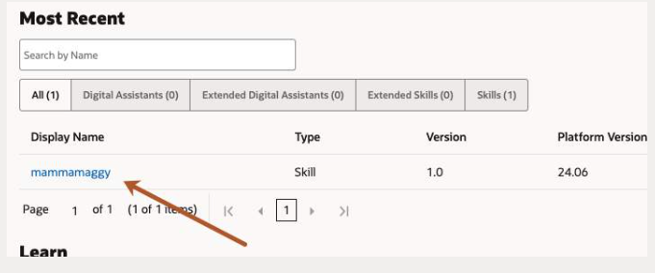

Start by creating a channel.

With the Oracle Digital Assistant UI open in your browser, click the **Hamburger** icon to open the side menu.

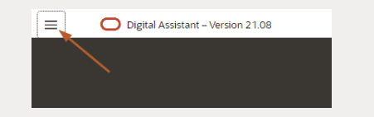

Click **Development** **⮕** **Channels**

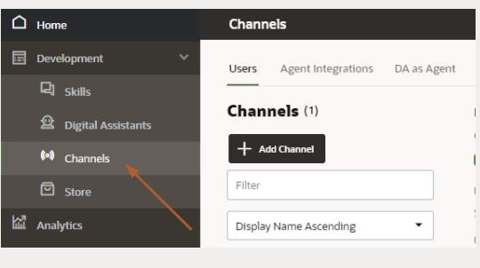

**Click the Hamburger icon  again to close the side menu and then + Add Channel to add a new channel.**

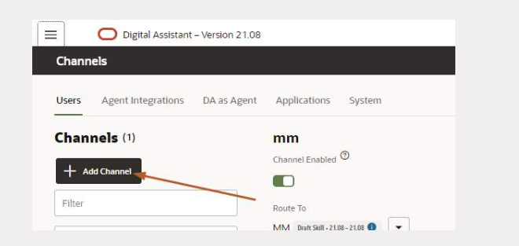

Enter the following details for this channel then click **Create** when done.

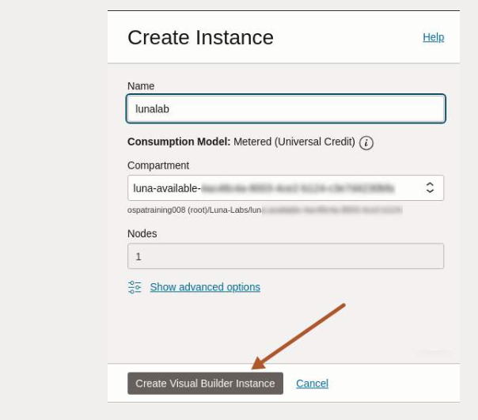

The instance has the status Creating.

The Visual Builder will take around three minutes to complete. Let's continue with the lab and check the staus later.

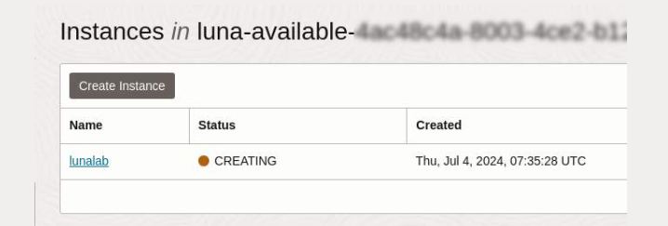

Go back to ODA through the **OCI Console**homepage.

Click the **Hambuger icon ⮕ Analytics & AI ⮕ Digital Assistant**.

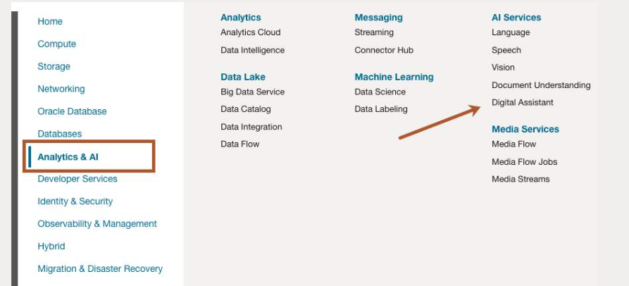

Click the **option icon** **⮕ Service Console.**

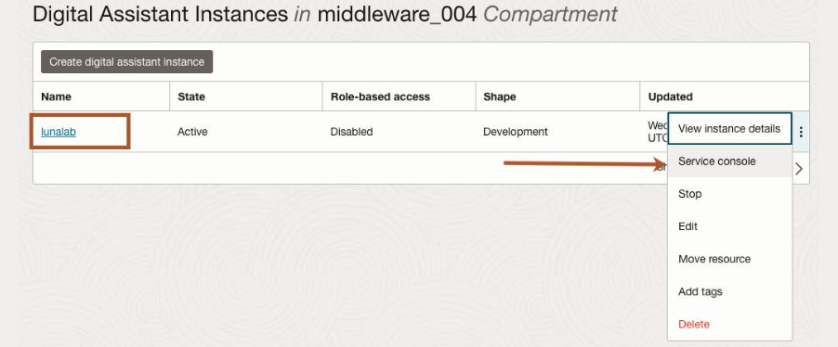

**Select your digital assistant created earlier.**

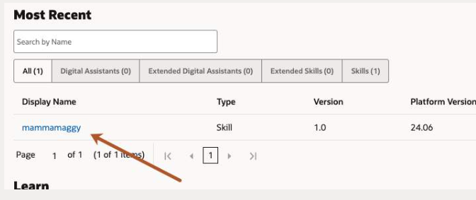

**Start by creating a channel.**

With the Oracle Digital Assistant UI open in your browser, click the Hamburger icon to open the side menu.

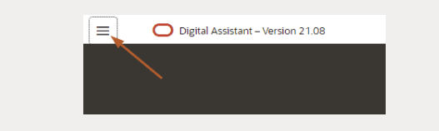

Click **Development** **⮕** **Channels**.

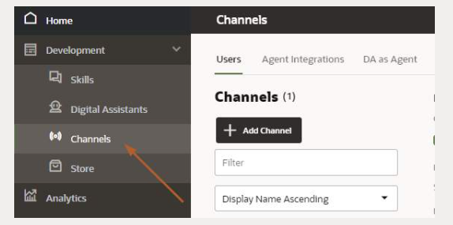

Click the **Hamburger icon** again to close the side menu and then **+ Add Channel** to add a new channel.

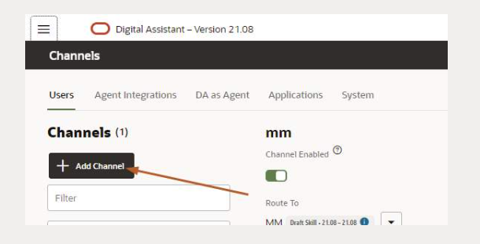

Enter the following details for this channel then click **Create** when done.

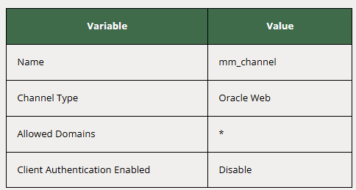

Your screen should look something like this

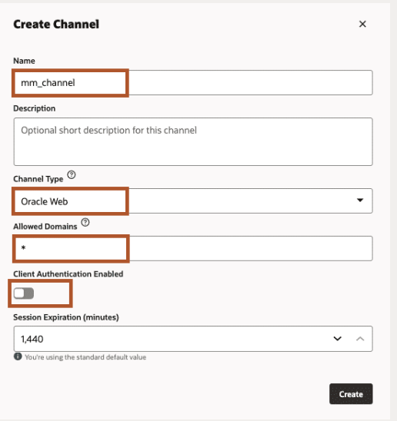

In **Route To**, set it to the skill you created earlier.

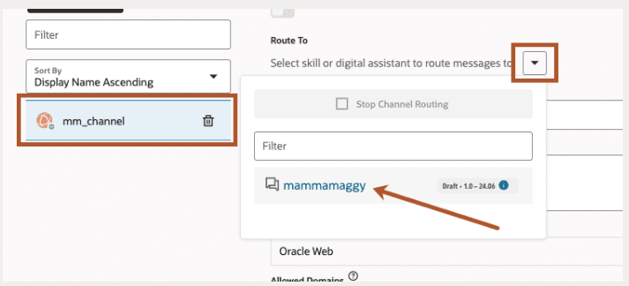

The**Channel Enabled** is on.

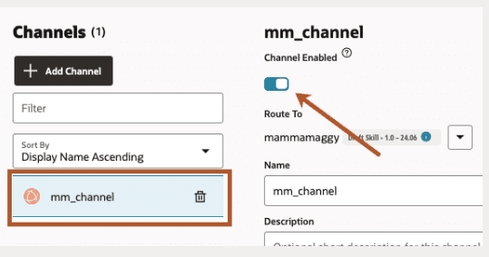

To use the assistant in our web application, we will need the channel **URI** and the **Channel Id**.

Copy the **URI** without the **https://** to a notepad (URI is the part between the // and the first /).

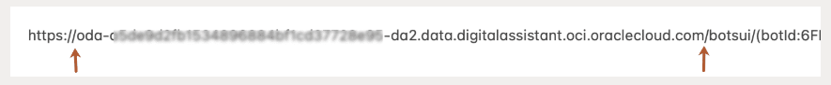

Copy the **Channel Id** to a notepad.

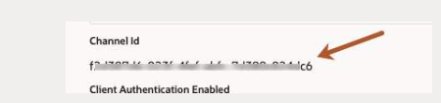

You are now ready to build your web application in Visual Builder!

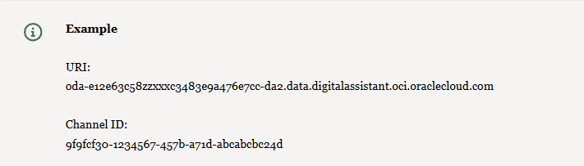

We can now build our application in Visual Builder, go to the Visual Builder instance you just created.

Continue with this lab when the the instance has the status **ACTIVE.**

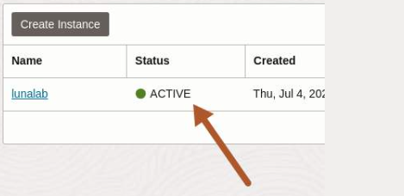

Click your **VBCS instance** **⮕** **Service homepage** to start building you app in Visual Builder.

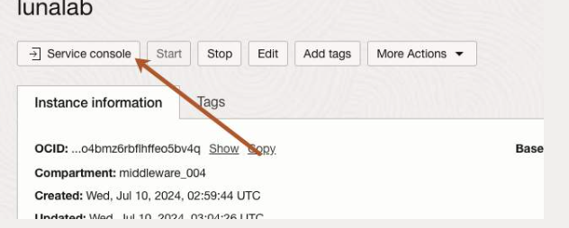

Choose the **New** button when the **Visual Applications** welcome page appears.

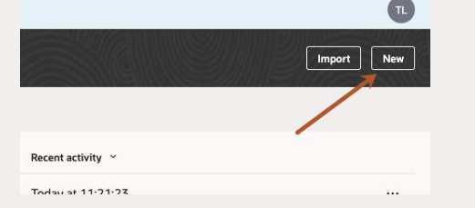

On the **Create Application**page, provide a name for the application and check the **Empty Application**template is selected.

Click **Finish** to continue.

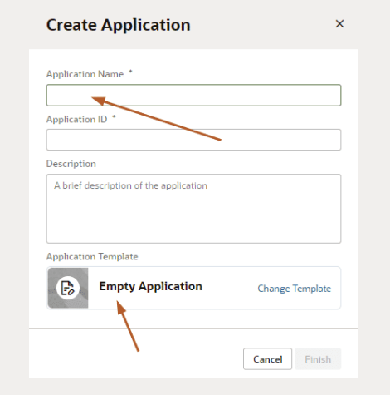

Click the **Web Application**icon.

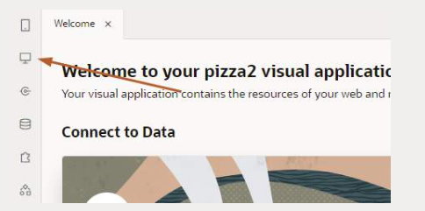

Select the **+** to add a web app and enter a name for your app.

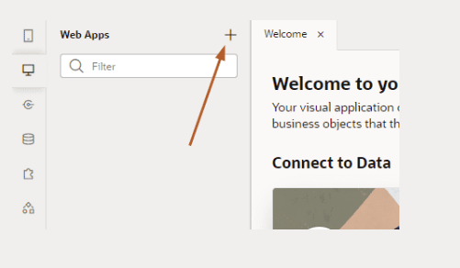

Right-click your app, select **Import** and select **Desktop**⮕**labfiles**  ⮕ **pizza_app.zip**.

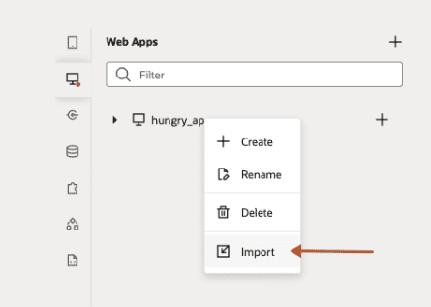

Click **Source** and find the **settings.js** file.

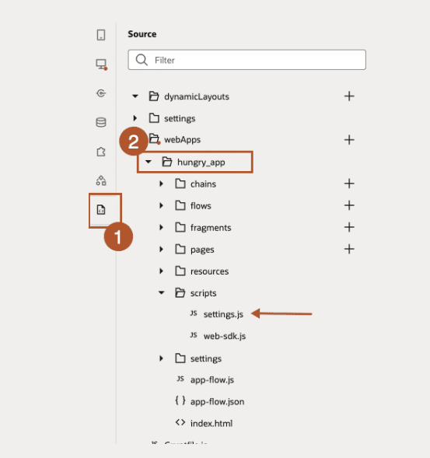

In the **settings.js**file enter the ODA connecting values.

Copy and paste the **MY_URI** and **MY_CHANNEL_ID** you saved earlier.

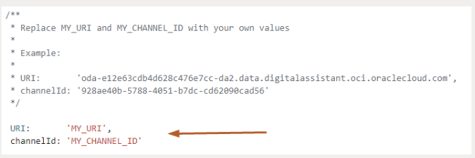

It should look like this.

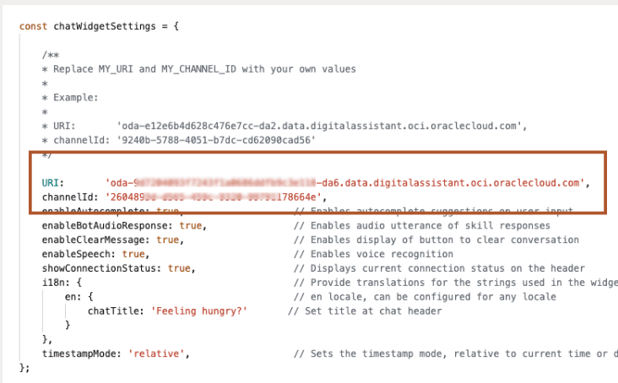

Click the play button located at the top right of your screen to test

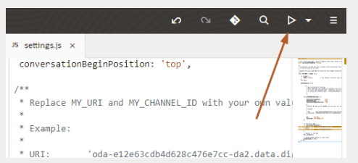

You should see the web app screen with the skill icon at the **bottom right**.

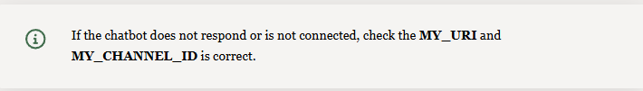



Type the following and press enter to test

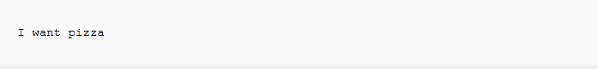

You will experience the same behavior in testing the Digital Assistant that you had created earlier.

Finally, let's use one of the message created during the training process. Type the following message then press enter.

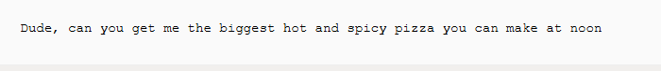

The output should look something like this.

